TA
Created on Monday, December 18, 2006
Copyright & Trademarks
Copyright © 2003, 2006, Oracle. All rights reserved. Powered by OnDemand Software. Distributed by Oracle under license from Global Knowledge Software LLC. © 1998-2006. All rights reserved.

The information contained in this document is subject to change without notice. If you find any problems in the documentation, please report them to us in writing. This document is not warranted to be error-free. Except as may be expressly permitted in your license agreement for these Programs, no part of these Programs may be reproduced or transmitted in any form or by any means, electronic or mechanical, for any purpose.

If this documentation is delivered to the United States Government or anyone using the documentation on behalf of the United States Government, the following notice is applicable:

U.S. GOVERNMENT RIGHTS
The U.S. Government’s rights to use, modify, reproduce, release, perform, display, or disclose these training materials are restricted by the terms of the applicable Oracle license agreement and/or the applicable U.S. Government contract.

Oracle, JD Edwards, PeopleSoft, and Siebel are registered trademarks of Oracle Corporation and/or its affiliates. Other names may be trademarks of their respective owners.

Table of Contents
How to Apply to a Posting 1
Applicant Tutorial 1

How to Apply to a Posting

Applicant Tutorial
This lesson will guide applicants through the application process. It will include instructions on how to search job postings, create a username and password, create a profile, and attaching documents

Procedure

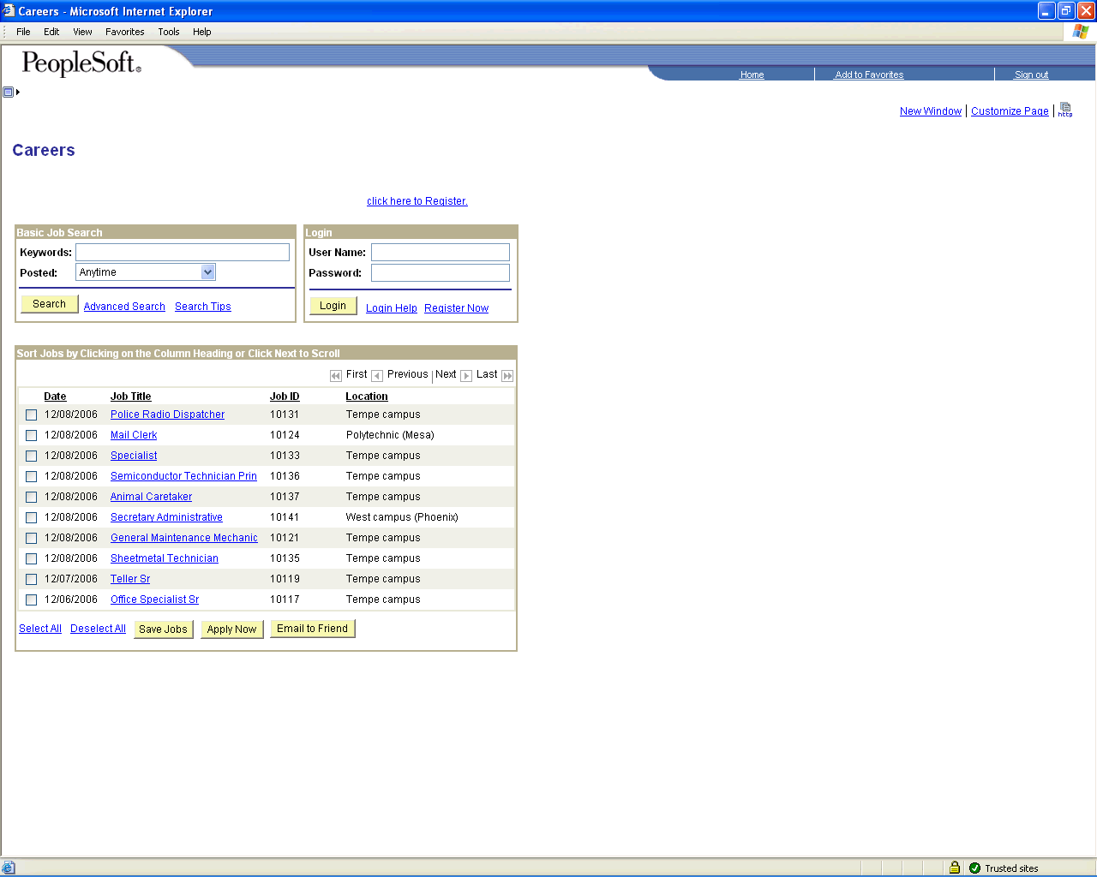

Step | Action
 | Click the Posting Title link.

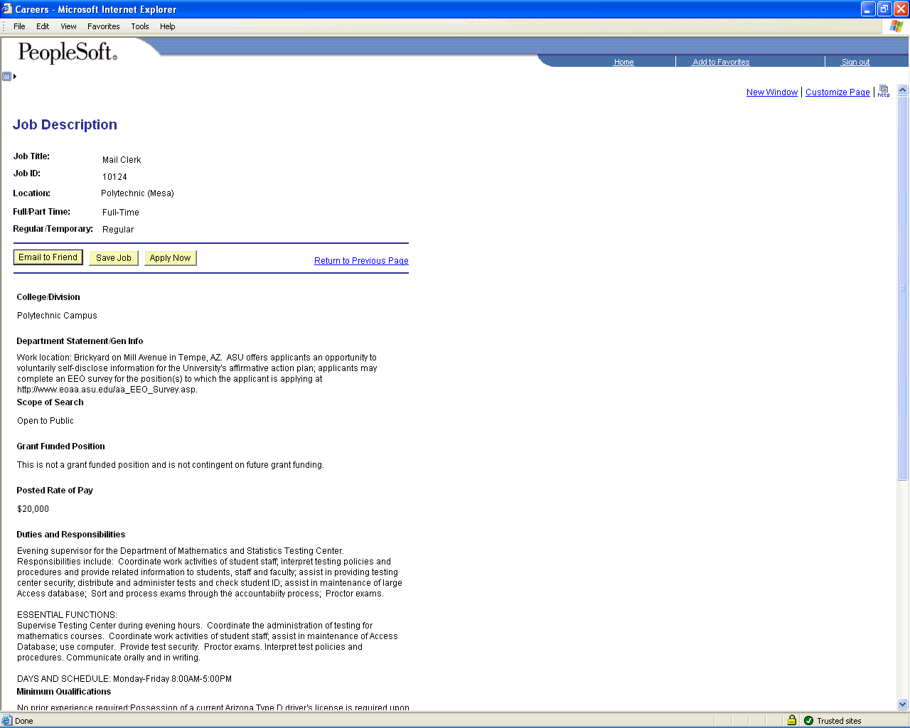

Step | Action
 | Scroll the object with the mouse wheel.

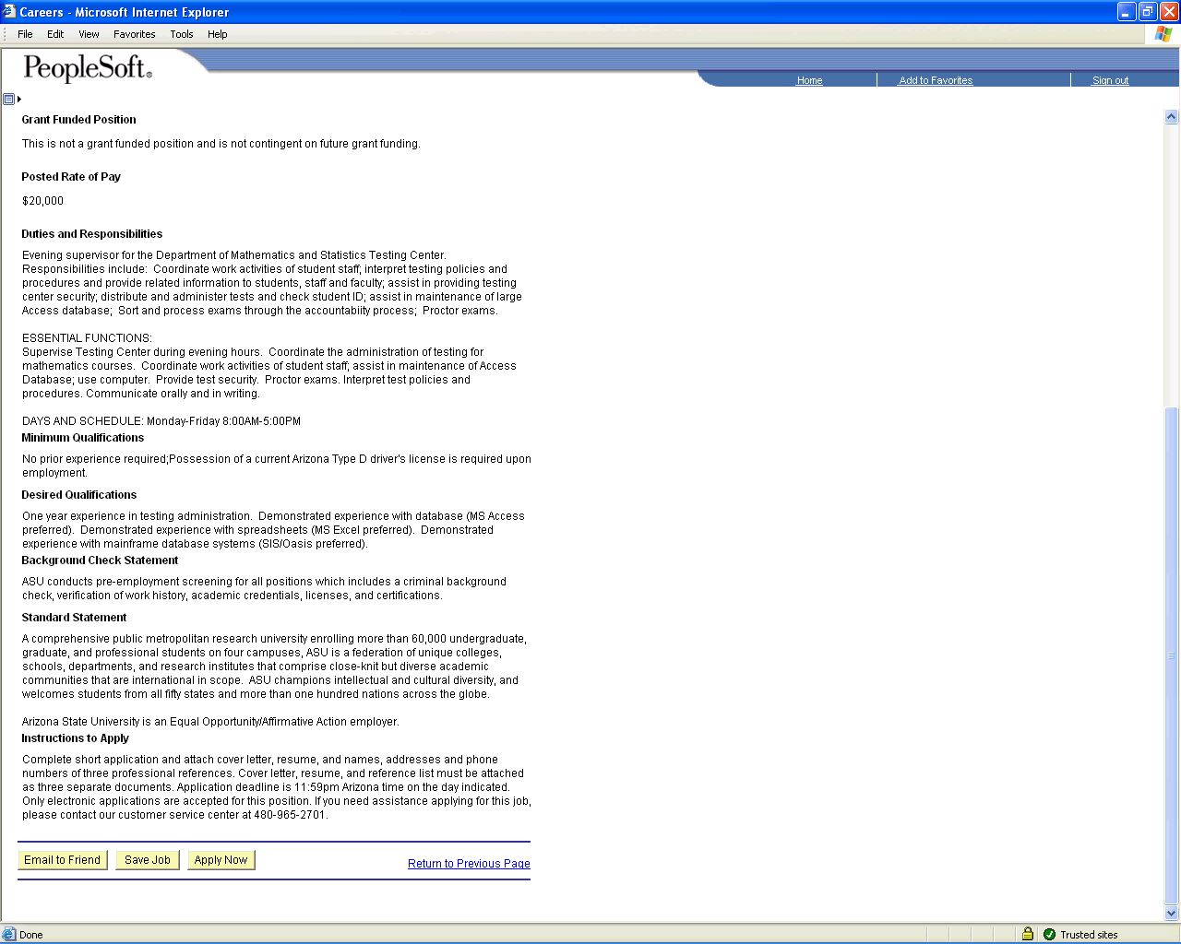

Step | Action
 | Click the Apply Now button.

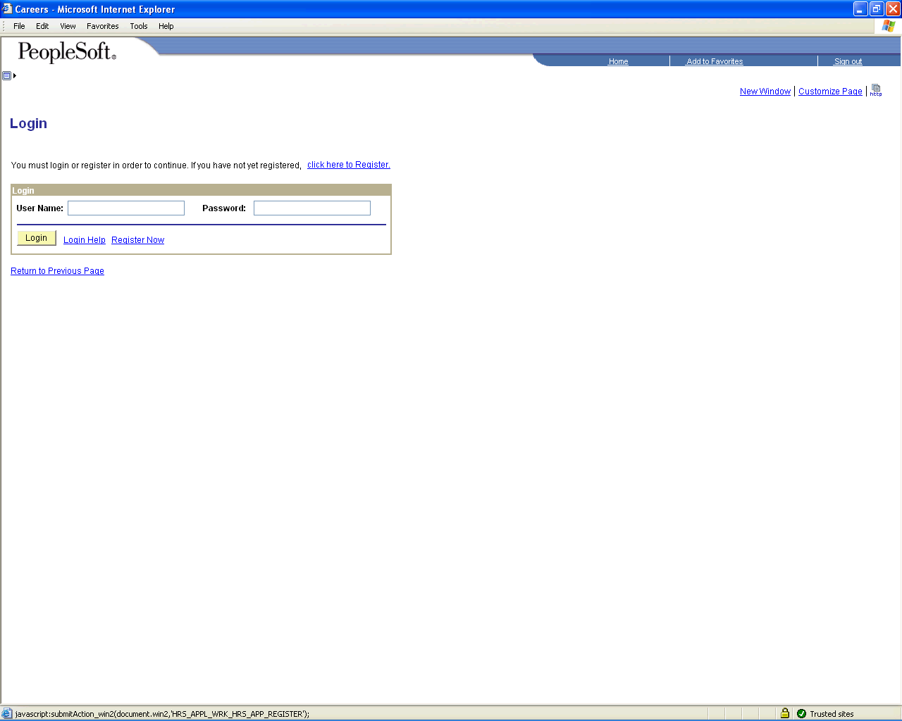

Step | Action
 | Click the click here to Register. link.

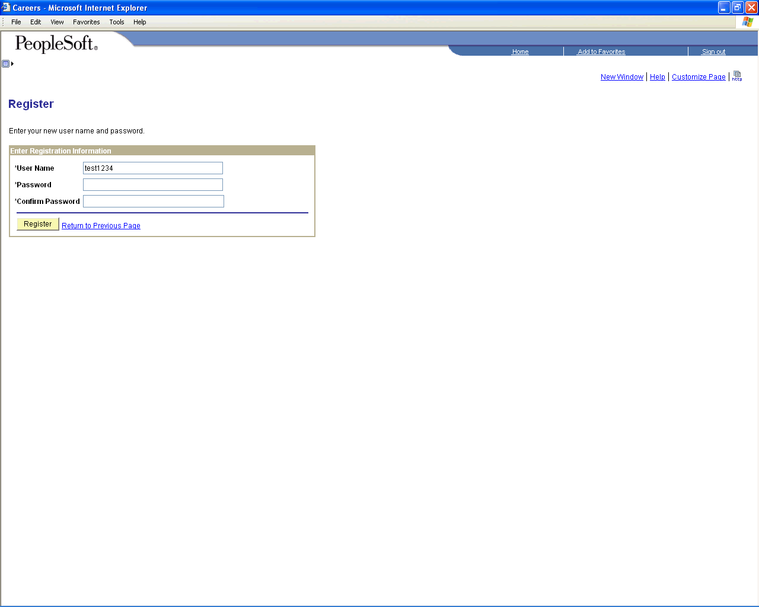

Step | Action
 | Click the object.
 | Click the object.

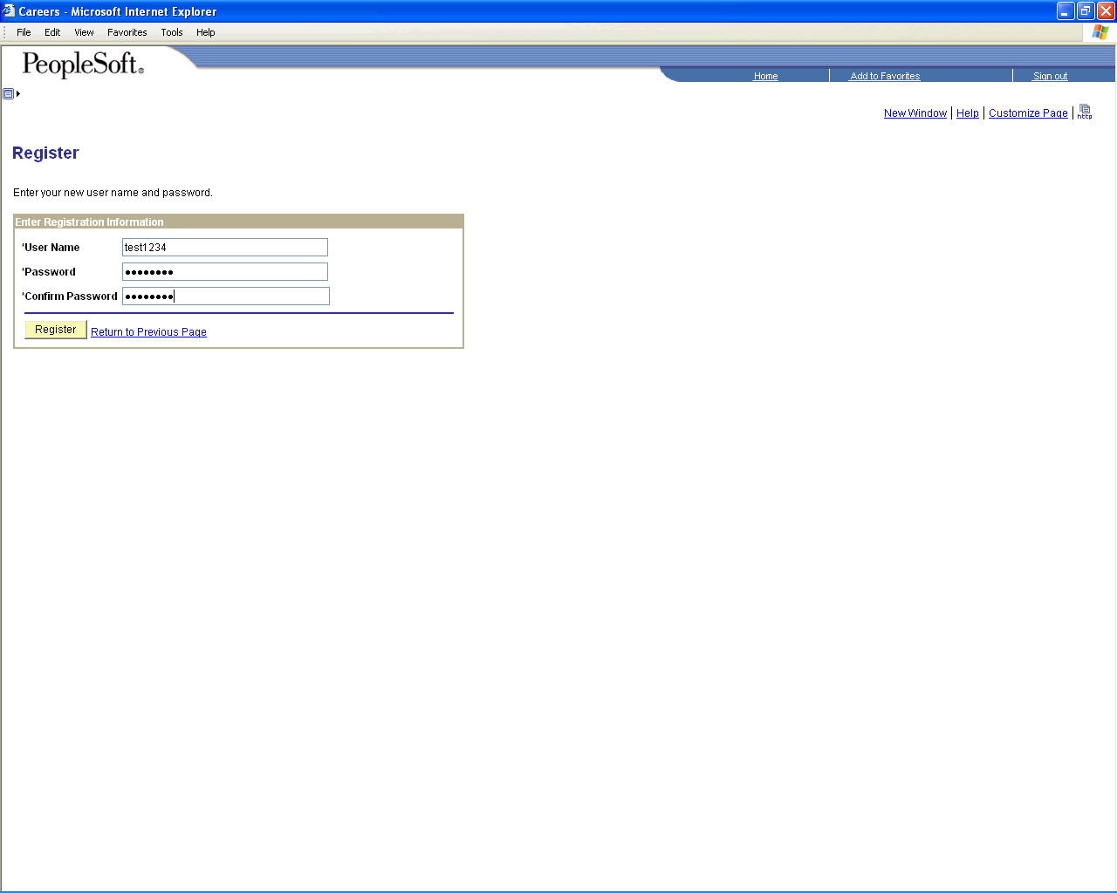

Step | Action
 | Click the Register button.
 | Click the Continue button.

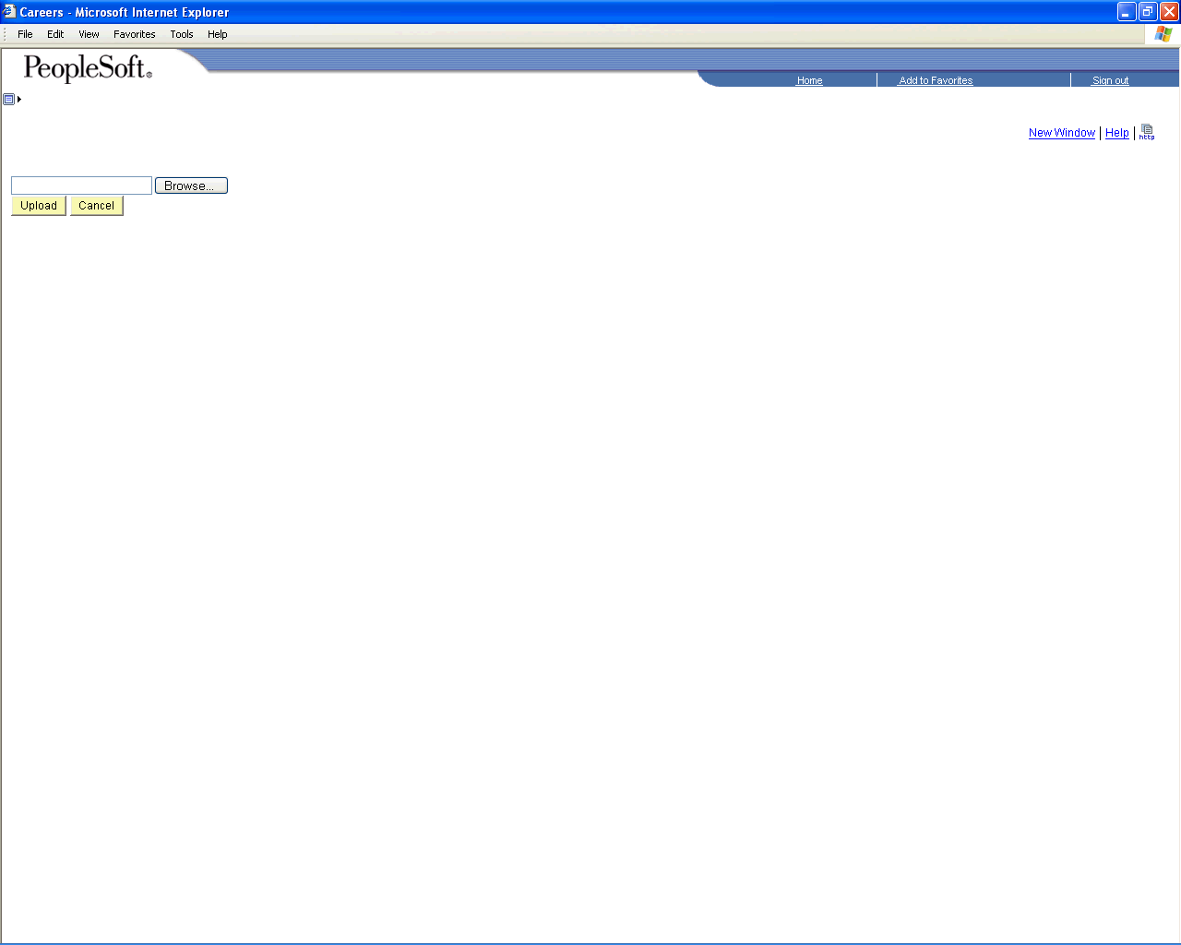

Step | Action
 | Click the Open button.
or
Press [Alt+O].

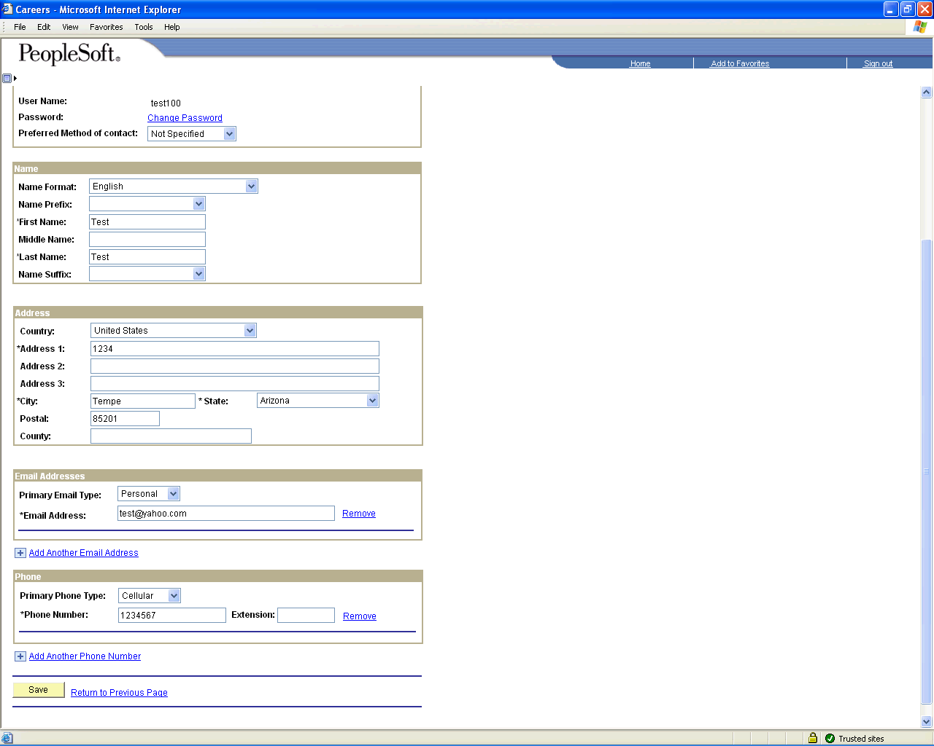

Step | Action
Click the object.

Complete all sections highlighted below

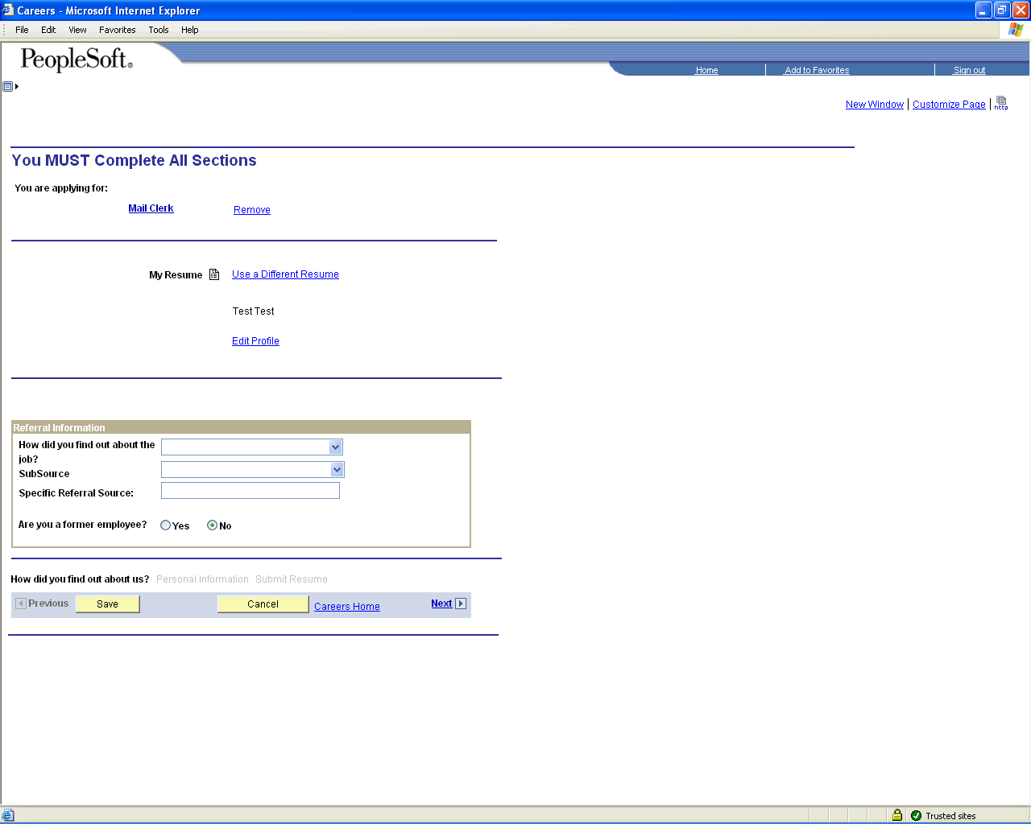

Step | Action
 | Click the list.
 | Click an entry in the list.
 | Click the SubSource list.
 | Click an entry in the list.
 | Click the Next link.
Click the Date of Birth object.

Date of Birth is not a required field
 | Click the Gender list.
Click an entry in the list.
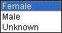
 | Click the Next link.
 | Click the Submit button.

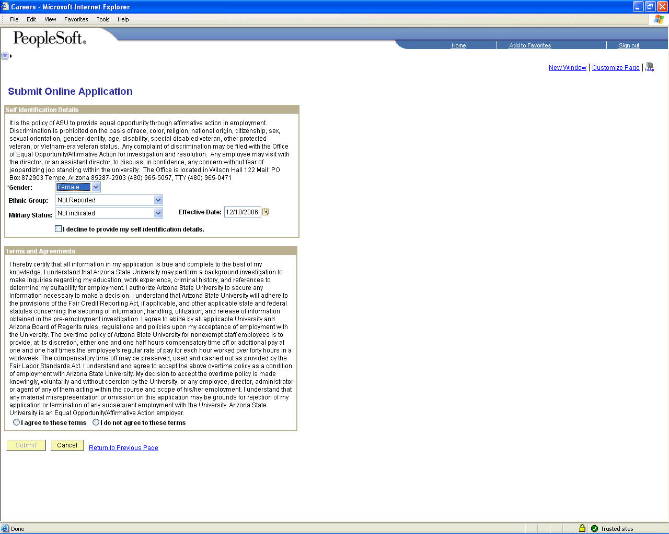

Step | Action
Click the Ethnic Group list.

Not a required field
Click the Ethnic Group list.

Not a required field

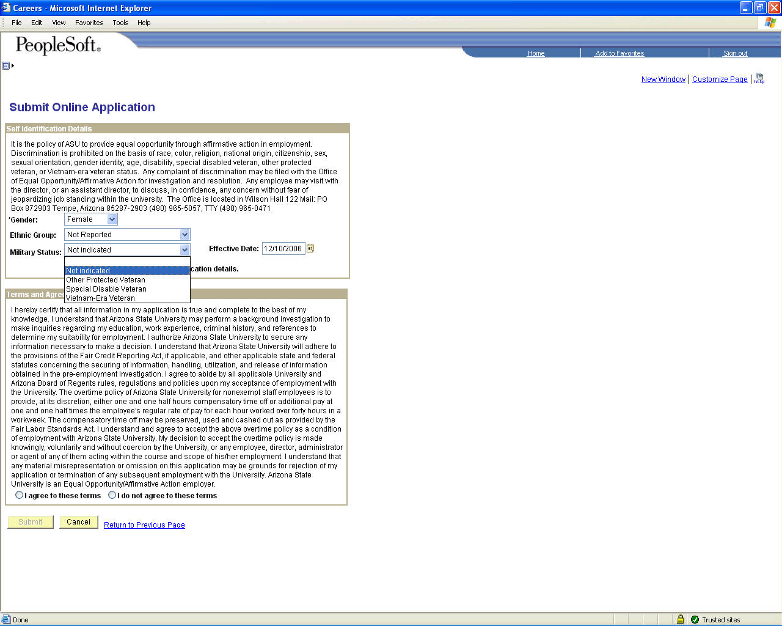

Step | Action
 | Click the Military Status dropdown button to activate the menu.

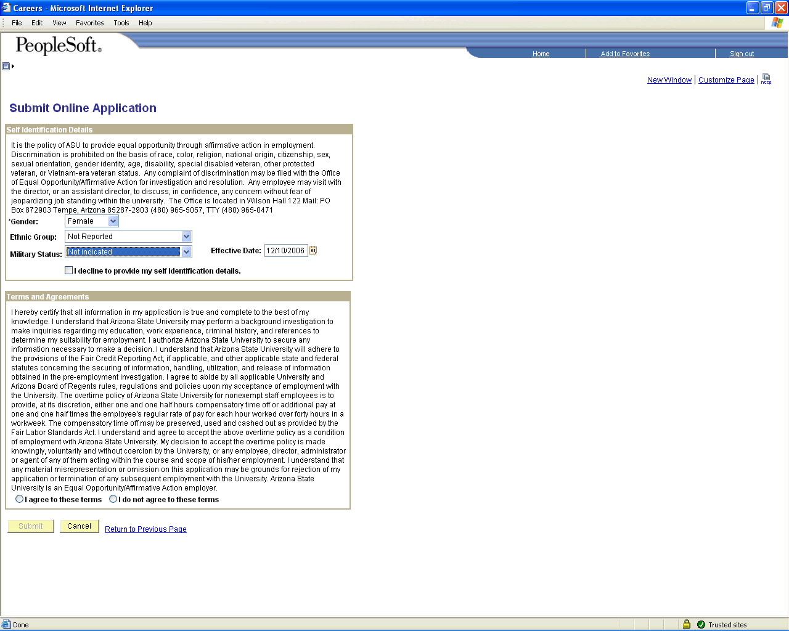

Step | Action
Click the I decline to provide my self identification details. option.

Click here is you do not wish to self identify
Click the I agree to these terms option.

Applicants must agree to Terms and Agreements in order to submit application.
 | Click the Submit button.

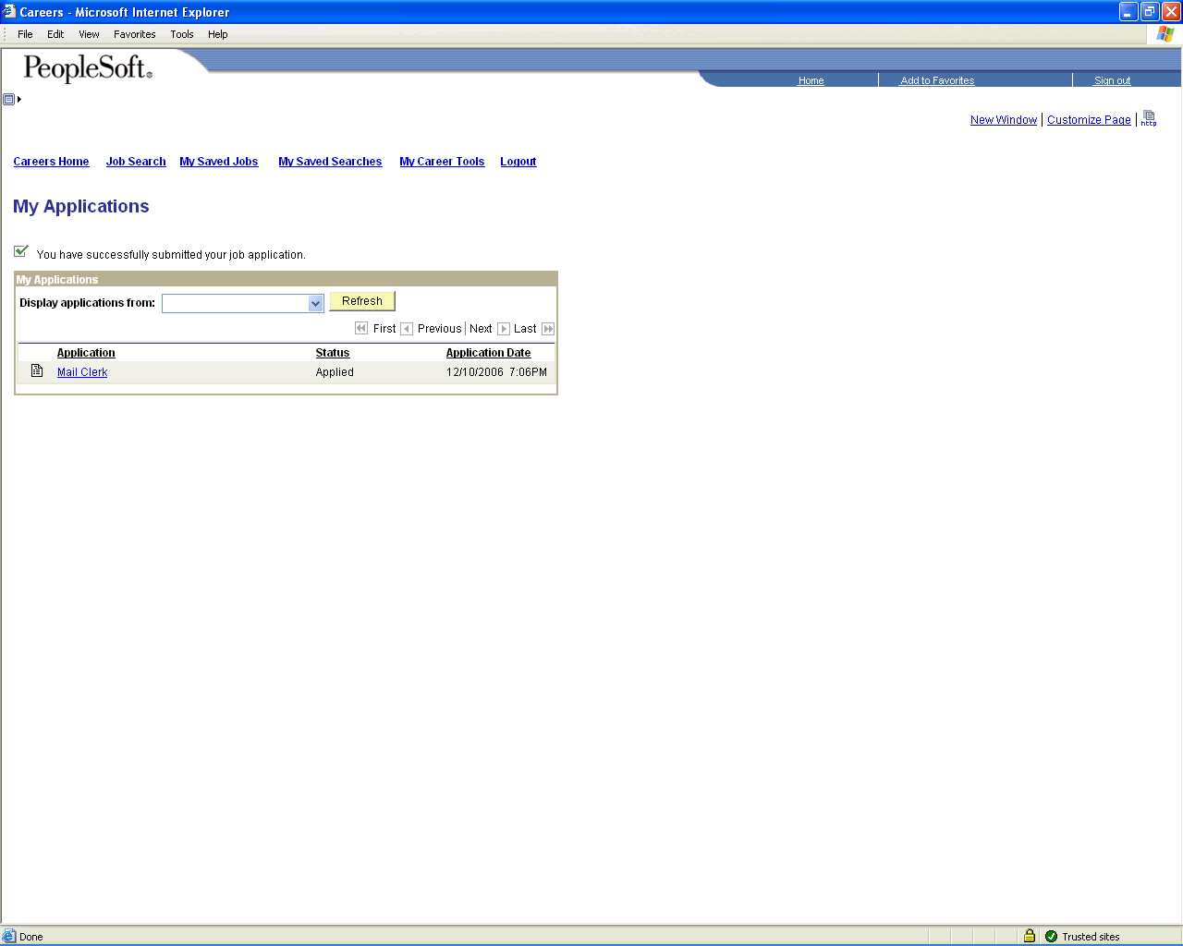

Step | Action
 | Click the Careers Home link.
 | End of Procedure.

