ADVANTAGE
Table Look Ups



Open Document Table Updating 1
Accessing Open Tables from the Custom Desktop 2
Navigating Open Tables 5
Maximizing Windows 6
Looking Up Internal Purchase Orders 7
OPOH - Open PO Header Table 8
OPOL - Open PO Line Table 10
OPOD - Open PO Header by Document Inquiry 11
Looking Up Off-Campus Order Documents (PC, PD, and SC)
By Document ID 12
OPHD - Open PC/PD/SC Header by Document Inquiry 13
OPLD - Open PC/PD/SC Accounting Line by Document Inquiry 16
OPCD - Open PC/PD/SC Commodity Line by Document Inquiry 17
OPPD - Open PC/PD/SC by Document Number 20
By Vendor ID 21
OPPH - Open PC/PD/SC Header by Vendor 22
OPPL - Open PC/PD/SC Line Table 24
OPPC - Open PC/PD/SC Commodity Table 25
By Agency/Org 26
OPIV - Open PC/PD/SC by Agency Org and Vendor Inquiry 27
Looking Up Off-Campus Order Modification Documents 29
MPPH - Open PC/PD/SC Header Modification Inquiry 30
MPPL - Open PC/PD/SC Account Line Modification Inquiry 32
MPPC - Open PC/PD/SC Commodity Line Modification Inquiry 33
Looking Up Payment Voucher (PV) Documents 34
OPVD - Open Payment Voucher by Document Number Inquiry 35
OPVH - Open Payment Voucher Header Table 37
OPVL - Open Payment Voucher Line (1 of 2) 38
OPV2 - Open Payment Voucher Line (2 of 2) 40
Looking Up Receiver (RC) Documents 41
ORCH - Open Receiver Header Table 42
ORCL - Open Receiver Accounting Line Table 44
Looking Up Requisition (RX) Documents 45
ORQH - Open RX Header Table 46
ORQL - Open RX Account Line Table 49
ORQC - Open RX Commodity Line Table 50
RQST - Requisition Status Table 51
RSTA - Requisition Status Code Table 53
Looking Up ASU Stores Stock Requisition (SR) Documents 54
OSRH - Open Stock Requisition Header Inquiry 55
OSRL - Open Stock Requisition Account Line Inquiry 57
OSRC - Open Stock Requisition Line Inquiry 58
OSRI - Open Stock Requisition Items Issue Inquiry 59
Looking Up Vendor Invoice (VI) Documents 60
OVIH - Open Vendor Invoice Header 61
OVIL - Open Vendor Invoice Line 64
Looking Up Check Status 65
OPCH - Open Check Header 66
OPCL - Open Check Line 68
Document History Tables 69
DXRF - Document Cross-Reference 70
DHIS - Document History 72
RQST - Requisition Status Table 73
Open Document Table Updating
DOCUMENTS |  | TABLES
PO |  | OPOD Open PO by Document Inquiry  OPOH Open PO Header Table  OPOL Open PO Line Table
PC, PD, SCS  (by Document ID) |  | OPHD Open PC Header by Document Inquiry  OPLD Open PC Account Line by Document Inquiry  OPCD Open PC Commodity Line by Document Inquiry  OPPD Open PC by Document Number
PC, PD, SCS  (by Vendor ID) |  | OPPH Open PC Header by Vendor  OPPL Open PC Line Table  OPPC Open PC Commodity Table  OPIV Open PC by Agency Org and Vendor Inquiry
PV |  | OPVD Open Payment Voucher Header by Doc Number  OPVH Open Payment Voucher Header  OPVL Open Payment Voucher Line (1 of 2)  OPV2 Open Payment Voucher Line (2 of 2)
RC |  | ORCH Open Receiver Header Table  ORCL Open Receiver Line Table
RX |  | ORQH Open RX Header Table  ORQL Open RX Line Table  ORQC Open RX Commodity Table  RQST Requisition Status Table
SR |  | OSRH Open Stores Requisition Header Inquiry  OSRL Open Stores Requisition Account Line Inquiry  OSRC Open Stores Requisition Line Inquiry  OSRI Open Stores Requisition Items Issue Inquiry
VI |  | OVIH Open Vendor Invoice Header  OVIL Open Vendor Invoice Line
AD & MW |  | OPCH Open Check Header  OPCL Open Check Line
ALL DOCUMENTS |  | DXRF Document Cross Reference Table  DHIS Document History Detail Table
The above tables update immediately except for the DXRF and DHIS tables, which update during nightly processing. All documents that are accepted into Advantage appear on Monthly Reports after month-end close.
Accessing Open Tables from the Custom Desktop
One of the features of the Custom Desktop in Advantage is a drop-down menu that allows you to access the Open Tables for a specific series of documents.
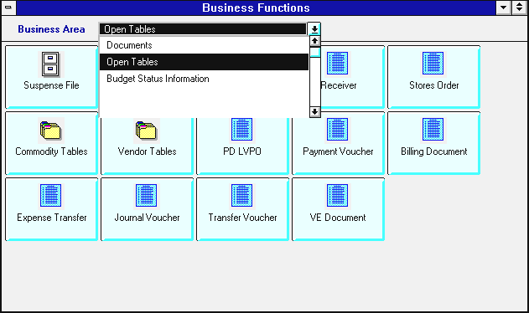
To access the Open Tables Window from the Custom Desktop:
- Click on the Business Area drop-down menu.
- Select Open Tables.
The Open Tables Window
The Open Tables window will appear. From this window, you can select the series of Open Tables which contain information on the type of document you wish to view.

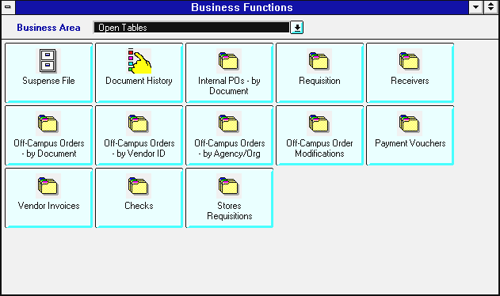
- Click on the button that corresponds to Open Tables for the type of document you wish to view.
- Refer to the chart on the next page for a detailed listing of the tables linked to each button on this screen.
The following chart illustrates the tables you can access by clicking on a particular button:
Clicking this button: | Allows you to access these tables: |  | Clicking this button: | Allows you to access these tables:
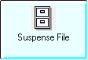 | The Suspense File. |  | 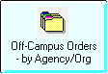 | OPIV
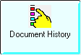 | DXRF, DHIS, and RQST |  | 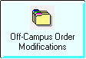 | MPPH, MPPL, and MPPC
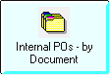 | OPOH, OPOL, and OPOD |  | 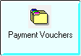 | OPVD, OPVH, OPVL, and OPV2
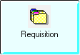 | ORQH, ORQL, ORQC, RQST, and RSTA |  | 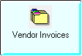 | OVIH and OVIL
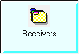 | ORCH and ORCL |  | 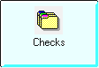 | OPCH and OPCL
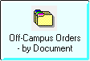 | OPHD, OPLD, OPCD, and OPPD |  | 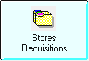 | OSRH, OSRL, OSRC, and OSRI
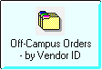 | OPPH, OPPL, and OPPC

Navigating Open Tables
Moving between Open Tables is accomplished via a series of buttons that appear at the bottom of each Open Table window. Below is an example of the Open Purchase Order Header Modification Inquiry table (MPPH) showing a Purchase Order modification document. The buttons at the bottom of the screen are used to move between tables, to minimize windows, and to exit to the Business Functions window.
Open Purchase Order Header Modification Inquiry (MPPH)
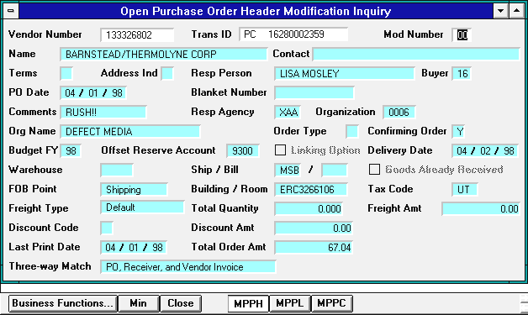

Button: | Function:
 | Activates the Business Functions window so it appears in front of any other windows you may have open.
 | Minimizes all the Open Table windows you are currently viewing including the Business Functions window.
 | Closes all the Open Tables windows you are viewing and returns you to the Business Functions window.
The depressed button at the bottom of the screen indicates the table name of the active window you are viewing. In this example, the MPPH table is the active window. Clicking on any of the buttons to the right will take you to that table and carry the information from the document you are currently viewing.
Maximizing Windows
Not all windows in Advantage will appear the same size on your screen. When moving between Open Tables, some windows may overlap, as shown below. The active window will be outlined by a dark border and may be maximized for easier viewing. The example below illustrates what will happen on the screen when moving from the MPPH table to the MPPL table.
Open Purchase Order Account Line Modification Inquiry (MPPL)
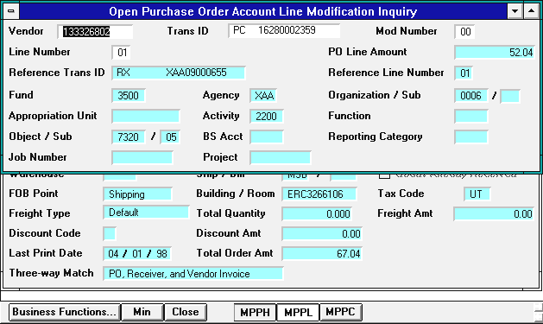
Inactive Window

The MPPL table is the active window but part of the inactive window (previous MPPH screen) can still be seen underneath.
Active Window
(note
dark
border)
To view only the active window (MPPL), simply maximize the window by clicking on the up arrow at the top right corner of the active window. This will not affect your ability to move between the other open tables.

Looking Up an Internal Purchase Order
To access the Open Tables for Internal PO documents:
- Click on the |  | button.

Open PO Header Table (OPOH)
The Open Purchase Order Header Inquiry table (OPOH) will appear. The OPOH table shows header information from PO documents.
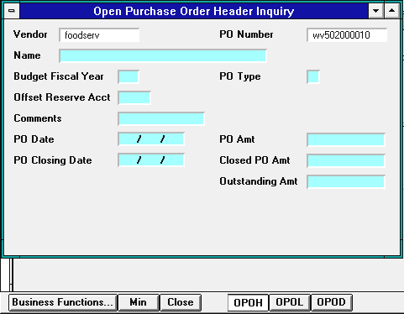
- Type the VENDOR CODE of the document you wish to view in the VENDOR field. ***If the PO was created before March 1, 2000, type NONE in the VENDOR field.
- Type the DOCUMENT ID NUMBER in the PO NUMBER field.
 | Toolbar | Key | Menubar
- Click on: |  | F4 | DISPLAY: BROWSE DATA

Open PO Header Table (OPOH)
The document header will appear on your screen.
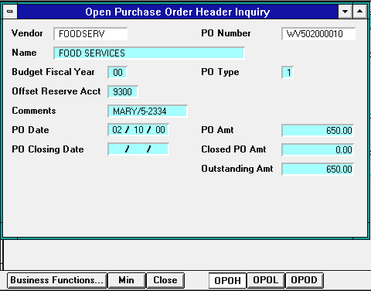
To view the next PO on the OPOH:
 | Toolbar | Key | Menubar
- Click on: |  | F5 | DISPLAY: MORE DATA

OR
To access the PO line information from the OPOL table:
- Click on the |  | button at the bottom of the screen.

Open PO Line Table (OPOL)
The line information from the Open Purchase Order Line Inquiry Table (OPOL) will appear on your screen.
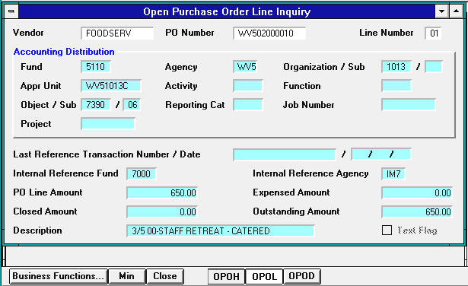
To view information for the next line of this document on OPOL:
 | Toolbar | Key | Menubar
- Click on: |  | F5 | DISPLAY: MORE DATA

OR
To view a listing of POs by document ID number and vendor code on the OPOD table starting with the document number you were viewing.
- Click on the |  | button at the bottom of the screen.

Open PO Document Table (OPOD)
The Open Purchase Order by Document Number Inquiry (OPOD) table will appear. The OPOD table is a listing of on-campus Purchase Orders (POs) by document ID number and vendor code. The OPOD window will appear smaller than the previous OPOL screen, so you may wish to maximize the active OPOD window. (If necessary, for directions on maximizing windows see page 6.)
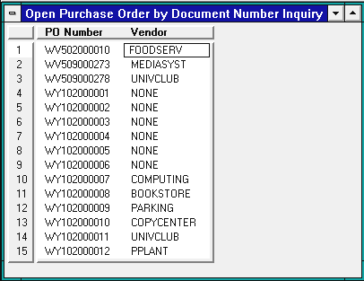

- The listing begins with the PO document number previously viewed on the OPOH/OPOL tables. The OPOD will reflect if a Service Department Vendor Code was used on the original document.
- Please note that PO documents created prior to March 1, 2000 will have a Vendor Code of NONE. For modification purposes, refer to the OPOL table for the Internal Reference Fund and Agency codes used on the original document.
- Purchase Order documents created after the March 1, 2000 will show the Vendor Code used in the original document on both the OPOD and OPOH tables.

Looking up an Off-Campus Order – by Document ID

In Advantage, accepted PC, PD, and SC documents are all found on the same series of open tables. To view an accepted PC, PD, or SC document, you may access the information through any of the Off-Campus Order buttons on the Open Tables window.

To view the Open Tables for Off-Campus Orders by Document Number:
- Click on the |  | button.

Open PC/PD/SC Header by Document Inquiry (OPHD)
The Open Purchase Order Header by Document Inquiry table will appear. The OPHD table allows you to view the Header information from PC documents by their document ID.
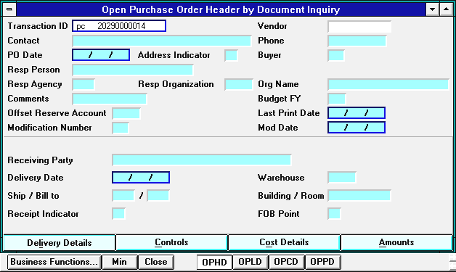
- Type PC, PD, or SC and the DOCUMENT ID NUMBER in the TRANSACTION ID field (e.g., pc 20290000014).
 | Toolbar | Key | Menubar
- Click on: |  | F4 | DISPLAY: BROWSE DATA

Open PC/PD/SC Header by Document Inquiry (OPHD)
The document header will appear on your screen in the Delivery Details View. This view shows the document header information and information regarding the delivery date and location.
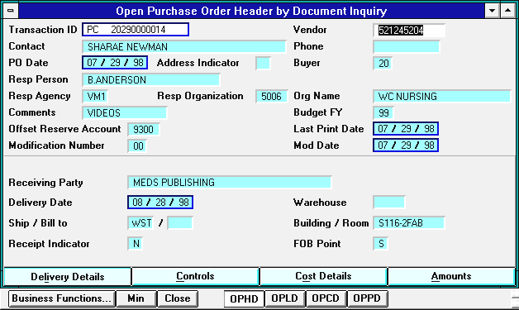
The Controls View shows control information for the header of this order. This view is seldom used.
The Cost Details View shows cost information regarding freight and discounts for the header of this order.
The Amounts View shows the total Ordered, Received, Invoiced, Outstanding, Expended, and Closed amounts of this order.
To switch to a different view, click on that button at the bottom of the OPHD window, e.g., to view the total amounts of this order:
- Click on:

Open PC/PD/SC Header by Document Inquiry (OPHD)
The document header will appear on your screen in the Amounts View.
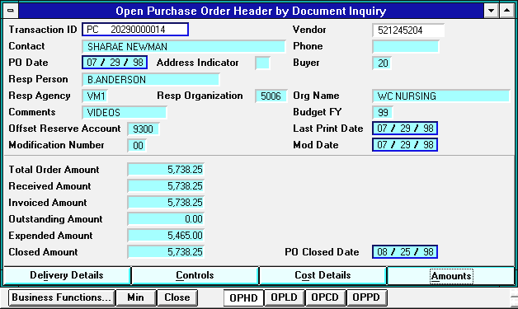

To view the next document on the OPHD:
 | Toolbar | Key | Menubar
- Click on: |  | F5 | DISPLAY: MORE DATA

OR
To access the accounting line information for this document:
- Click on the |  | button at the bottom of the screen.

Open PC/PD/SC Account Line by Document Inquiry (OPLD)
The accounting line information from the Open Purchase Order Account Line by Document Inquiry table (OPLD) will appear on your screen.
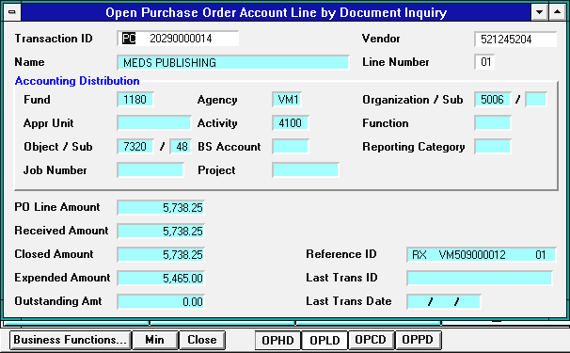

To view information for the next line of this document on the OPLD:
 | Toolbar | Key | Menubar
- Click on: |  | F5 | DISPLAY: MORE DATA

OR
To access the commodity line information for this document:
- Click on the |  | button at the bottom of the screen.

Open PC/PD/SC Commodity Line by Document Inquiry (OPCD)
The commodity line information from the Open Purchase Order Commodity Line by Document Inquiry table (OPCD) will appear in the Cost Details View. The OPCD window will appear smaller than the OPLD, so you may wish to maximize the OPCD window (see page 6 for directions on maximizing).
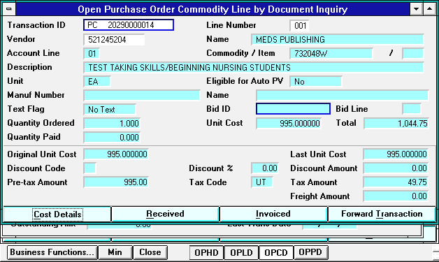

To view Cost Details information for the next commodity line of this document:
 | Toolbar | Key | Menubar
- Click on: |  | F5 | DISPLAY: MORE DATA

OR
To view information on what has been received on this commodity line:
- Click on:

Open PC/PD/SC Commodity Line by Document Inquiry (OPCD)
The commodity line information will appear in the Received View.
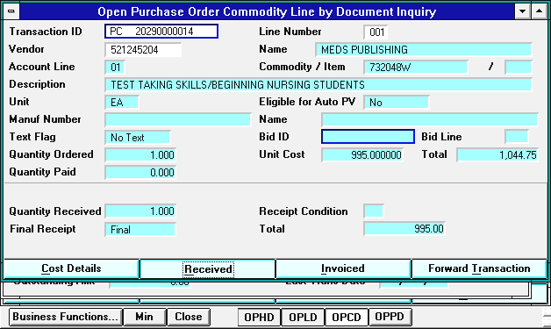

To view Received information for the next commodity line of this document:
 | Toolbar | Key | Menubar
- Click on: |  | F5 | DISPLAY: MORE DATA

OR
To view information on what has been invoiced on this commodity line:
- Click on:

Open PC/PD/SC Commodity Line by Document Inquiry (OPCD)
The commodity line information will appear in the Invoiced View.
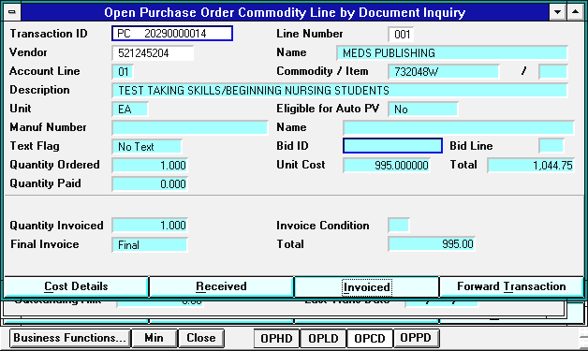

To view Invoiced information for the next commodity line of this document:
 | Toolbar | Key | Menubar
- Click on: |  | F5 | DISPLAY: MORE DATA

OR
To access a listing of off-campus orders by Document ID and Vendor code:
- Click on the |  | button at the bottom of the screen.

Open PC/PD/SC by Document Number Inquiry (OPPD)
The Open Purchase Order by Document Number Inquiry table (OPPD) will appear with the document you were just viewing at the top of the list. The OPPD is a listing of off-campus order documents by Document ID and Vendor code.
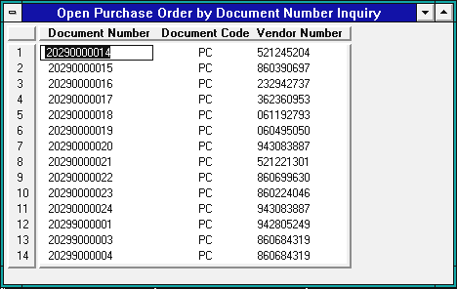
To view the next screen of information from this table:
 | Toolbar | Key | Menubar
- Click on: |  | F5 | DISPLAY: MORE DATA

Looking up an Off-Campus Order – by Vendor ID

To view the Open Tables for off-campus orders by Vendor Code:
- Click on the |  | button.

Open PC/PD/SC Header by Vendor Inquiry (OPPH)
The Open Purchase Order Header Inquiry table (OPPH) will appear.
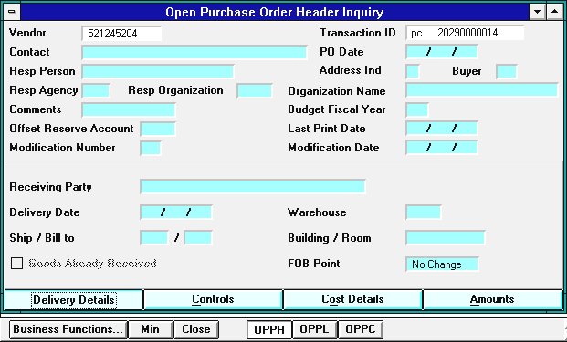
- Type the VENDOR CODE in the VENDOR field.
- Type PC, PD, or SC and the DOCUMENT ID NUMBER in the TRANSACTION ID field (e.g., pc 20290000014).
 | Toolbar | Key | Menubar
- Click on: |  | F4 | DISPLAY: BROWSE DATA

Open PC/PD/SC Header by Vendor Inquiry (OPPH)
The Open Purchase Order Header Inquiry table (OPPH) will appear in the Delivery Details View.** The OPPH table allows you to view the Header information from PC, PD, and SC documents by their Vendor code and Document ID.
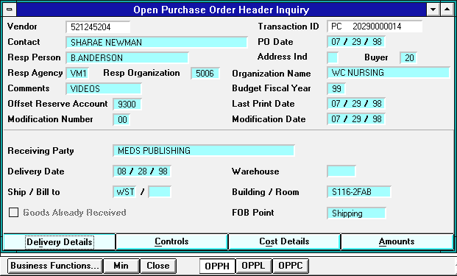
To view the next document on the OPPH:
 | Toolbar | Key | Menubar
- Click on: |  | F5 | DISPLAY: MORE DATA

OR
To access the accounting line information for this document:
- Click on the |  | button at the bottom of the screen.

**The OPPH table has the same Views as the OPHD table. See pages 15 and 16 for a description of each view and directions for accessing them.
Open PC/PD/SC Account Line by Vendor Inquiry (OPPL)
The line information from the Open Purchase Order Account Line Inquiry table (OPPL) will appear. The OPPL window will appear smaller than the OPPH screen, so you may wish to maximize the active OPPL window (see page 6 for directions on maximizing windows).
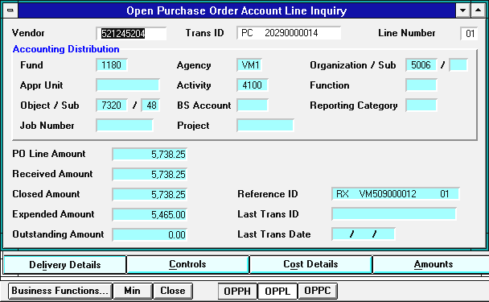

To view information for the next accounting line of this document:
 | Toolbar | Key | Menubar
- Click on: |  | F5 | DISPLAY: MORE DATA

OR
To access the commodity line information for this document:
- Click on the |  | button at the bottom of the screen.

Open PC/PD/SC Commodity Line by Vendor Inquiry (OPPC)
The commodity line information from the Open Purchase Order Commodity Line Inquiry table (OPPC) will appear in the Cost Details View.***
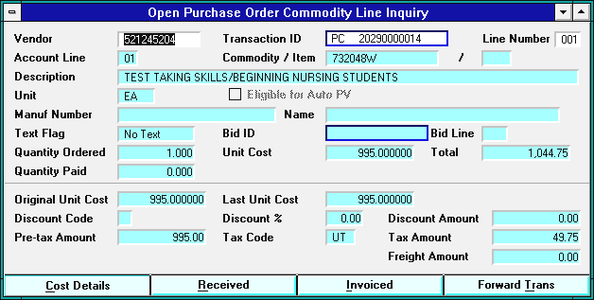

To view information for the next commodity line on this document:
 | Toolbar | Key | Menubar
- Click on: |  | F5 | DISPLAY: MORE DATA

***The OPPC table has the same Cost Details, Received, and Invoiced Views as the OPCD table. See pages 18, 19, and 20 for directions for accessing each view.
Looking up an Off-Campus Order – by Agency/Org

To view the Open Tables for off-campus orders by Agency/Org code:
- Click on the |  | button.

Open PC/PD/SC by Agency Org and Vendor Inquiry (OPIV)
The Open Purchase Order by Vendor Inquiry table (OPIV) will appear. The OPIV table is a listing of off-campus order documents by Agency/Org and Vendor code.
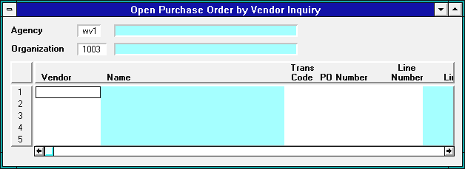
- Type the AGENCY CODE in the AGENCY field.
- Type the ORG CODE in the ORGANIZATION field.
 | Toolbar | Key | Menubar
- Click on: |  | F4 | DISPLAY: BROWSE DATA

The screen will refresh with a list in vendor code order of off-campus documents created under this agency/org.
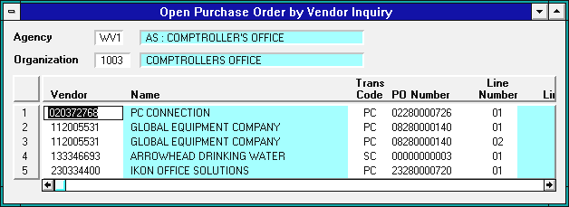

Open PC/PD/SC by Agency Org and Vendor Inquiry (OPIV)
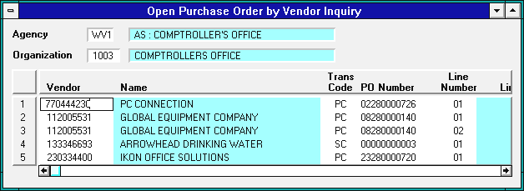
If you wish to view a list of documents created to a specific vendor under this agency/org:
- Type the VENDOR CODE in the VENDOR field.
 | Toolbar | Key | Menubar
- Click on: |  | F4 | DISPLAY: BROWSE DATA

The screen will refresh with the list of documents created under this agency/org to the requested vendor code:
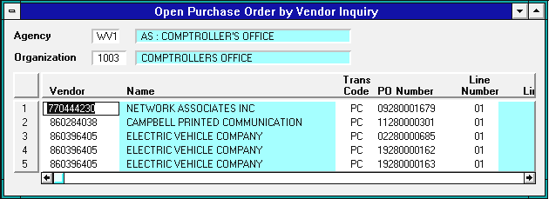
To view the next screen of off-campus orders:
 | Toolbar | Key | Menubar
- Click on: |  | F5 | DISPLAY: MORE DATA

Looking Up an Off-Campus Order Modification

To view the Open Tables for off-campus order modifications:
- Click on the |  | button.

Open Purchase Order Header Modification Inquiry (MPPH)
The Open Purchase Order Header Modification Inquiry table (MPPH) will appear. The MPPH table is a listing of off-campus order document modifications by Vendor code and Document ID Number.
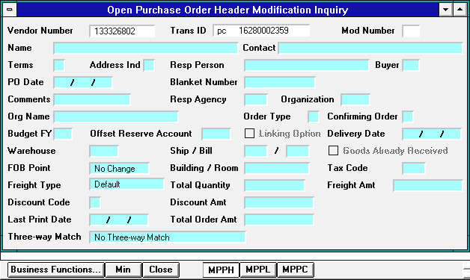
- Type the VENDOR CODE in the VENDOR field.
- Type the DOCUMENT TRANSACTION TYPE and the DOCUMENT ID NUMBER (e.g., pc 16280002359) in the TRANSACTION ID field.
 | Toolbar | Key | Menubar
- Click on: |  | F4 | DISPLAY: BROWSE DATA

Open Purchase Order Header Modification Inquiry (MPPH)
The screen will refresh with the requested document modification information:
To view the next document on the MPPH:
 | Toolbar | Key | Menubar
- Click on: |  | F5 | DISPLAY: MORE DATA

OR
To access the accounting line information for this document:
- Click on the |  | button at the bottom of the screen.

Open Purchase Order Account Line Modification Inquiry (MPPL)
The accounting line information from the Open Purchase Order Account Line Modification Inquiry table (MPPL) will appear. The MPPL window is smaller than the MPPH window so you may wish to maximize the active MPPL window (see page 6 for directions on maximizing the window).
To view the next accounting line for this modification document:
 | Toolbar | Key | Menubar
- Click on: |  | F5 | DISPLAY: MORE DATA

OR
To access the commodity line information for this modification document:
- Click on the |  | button at the bottom of the screen.

Open Purchase Order Commodity Line Modification Inquiry (MPPC)
The commodity line information from the Open Purchase Order Commodity Line Modification Inquiry table (MPPC) will appear.
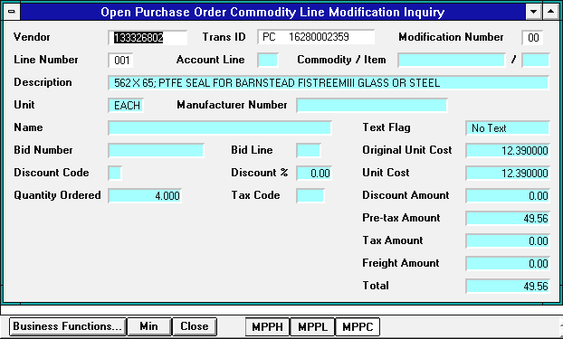
To view the next commodity line of this modification document:
 | Toolbar | Key | Menubar
- Click on: |  | F5 | DISPLAY: MORE DATA

Looking Up a PV Document

To view the Open Tables for Payment Voucher (PV) documents by Document ID Number:
- Click on the |  | button.

Open Payment Voucher by Document Number Inquiry (OPVD)
The Open Payment Voucher by Document Number Inquiry table (OPVD) will appear. The OPVD table is a listing of PV documents by Document ID Number.
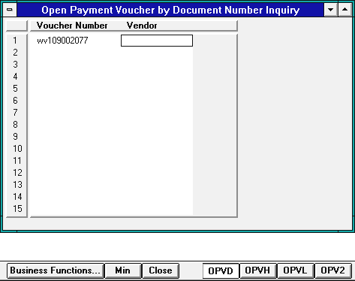

- Type the DOCUMENT ID NUMBER in the VOUCHER NUMBER field.
 | Toolbar | Key | Menubar
- Click on: |  | F4 | DISPLAY: BROWSE DATA

Open Payment Voucher by Document Number Inquiry (OPVD)
The screen will contain the Payment Voucher Document ID that you requested in the Voucher Number field. The Vendor code is listed alongside in the Vendor field.
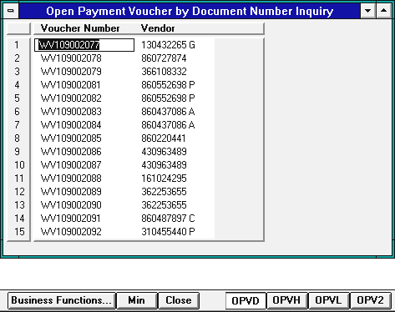
To view the next screen of information on the OPVD:
 | Toolbar | Key | Menubar
- Click on: |  | F5 | DISPLAY: MORE DATA

OR
To access Header information for this PV from the OPVH table:
- Click on the |  | button at the bottom of the screen.

Open Payment Voucher Header by Vendor Inquiry (OPVH)
The Open Payment Voucher Header table (OPVH) will appear. The OPVH table allows you to view the Header information from PV documents by Vendor code and Voucher Number.
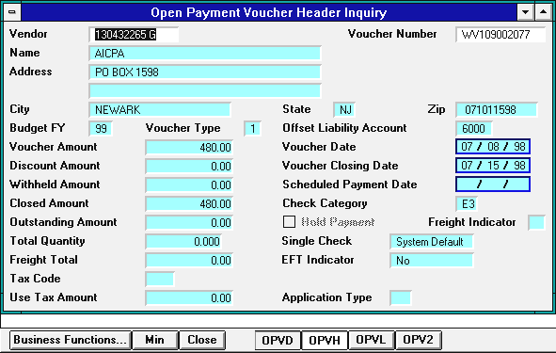
To view the next PV document on the OPVH:
 | Toolbar | Key | Menubar
- Click on: |  | F5 | DISPLAY: MORE DATA

OR
To access accounting line information for this PV from the OPVL table:
- Click on the |  | button at the bottom of the screen.

Open PV Line by Vendor and Voucher Number Inquiry (1 of 2)
The PV line information from the first screen of the Open Payment Voucher Line Inquiry table (OPVL) will appear in the Accounting Line View. The Accounting Line View shows the account that was charged and the object and subobject codes used on this line of the PV.
In addition, the OPVL window is smaller than the OPVH window so you may wish to maximize the active OPVL window (see page 6 for directions on maximizing).
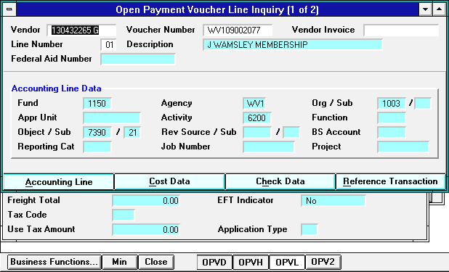
To view the next line of this PV in the Accounting Line View:
 | Toolbar | Key | Menubar
- Click on: |  | F5 | DISPLAY: MORE DATA

OR
To view the dollar amounts charged on this line of the PV in the Cost Data View:
- Click on:

Open PV Line by Vendor and Voucher Number Inquiry (1 of 2)
The line information will appear in the Cost Data View. The Accounting Line View shows the Voucher Line Amount, Disbursed Amount and Closed Amount for this line of the PV document.
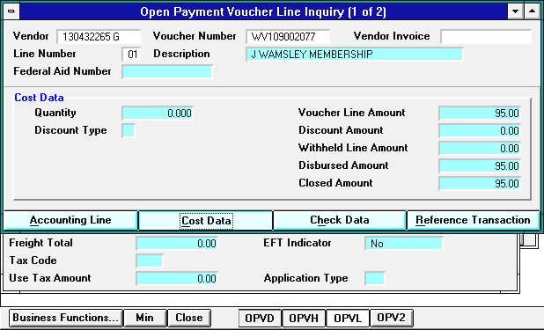
To view dollar amounts for the next line of this PV in the Cost Data View:
 | Toolbar | Key | Menubar
- Click on: |  | F5 | DISPLAY: MORE DATA

OR
To view the line description and additional information for this line of the PV:
- Click on the |  | button at the bottom of the screen.

Open PV Line by Vendor and Voucher Number Inquiry (2 of 2)
The PV line description and other information from the second screen of the Open Payment Voucher Line Inquiry table (OPV2) will appear:
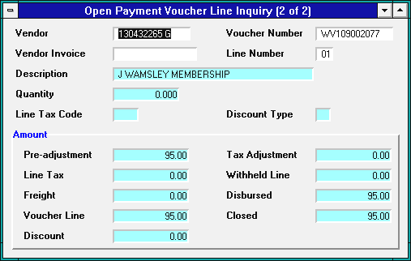
To view information from the next line of this PV on the OPV2:
 | Toolbar | Key | Menubar
- Click on: |  | F5 | DISPLAY: MORE DATA

Looking Up RC Documents

To view the Open Tables for RC documents by Document ID Number:
- Click on the |  | button.

Open Receiver Header Inquiry (ORCH)
The Open Receiver Header Inquiry table (ORCH) will appear. The ORCH table allows you to view Header information from Receiver (RC) documents by Document ID Number. ORCH will appear as a very small window towards the top of your screen. You may wish to maximize it (see page 6 for directions on maximizing).
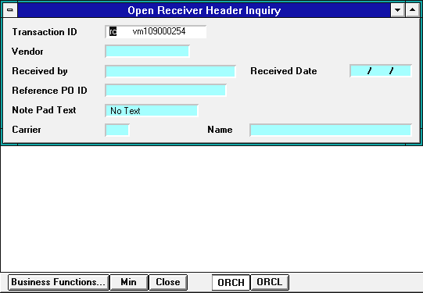

- Type RC and the DOCUMENT ID NUMBER in the TRANSACTION ID field.
 | Toolbar | Key | Menubar
- Click on: |  | F4 | DISPLAY: BROWSE DATA

Open Receiver Header Inquiry (ORCH)
The RC document header will appear on your screen.
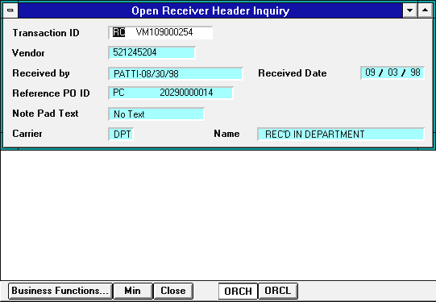

To view the next RC on the ORCH:
 | Toolbar | Key | Menubar
- Click on: |  | F5 | DISPLAY: MORE DATA

OR
To access the commodity line information for this RC:
- Click on the |  | button at the bottom of the screen.

Open Receiver Line Inquiry (ORCL)
The commodity line information from the Open Receiver Line Inquiry table (ORCL) will appear.
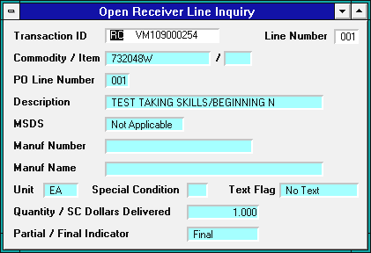

To view the next commodity line of this document on the ORCL:
 | Toolbar | Key | Menubar
- Click on: |  | F5 | DISPLAY: MORE DATA

Looking Up RX Documents

To view the Open Tables for RX documents by Document ID Number:
- Click on the |  | button.

Open Requisition Header Inquiry (ORQH)
The Open Requisition Header Inquiry table (ORQH) will appear. The ORQH table allows you to view the Header information on RX documents by Document ID Number.
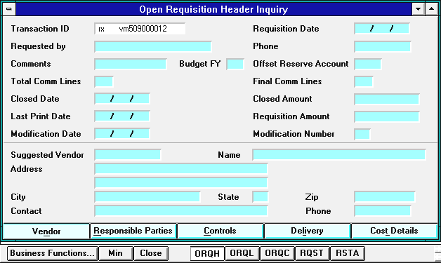

- Type RX and the DOCUMENT ID NUMBER in the TRANSACTION ID field.
 | Toolbar | Key | Menubar
- Click on: |  | F4 | DISPLAY: BROWSE DATA

Open Requisition Header Inquiry (ORQH)
The RX document header will appear on your screen in the Vendor View. The Vendor View shows the Vendor's tax ID number, name, address, and phone number below the document header.
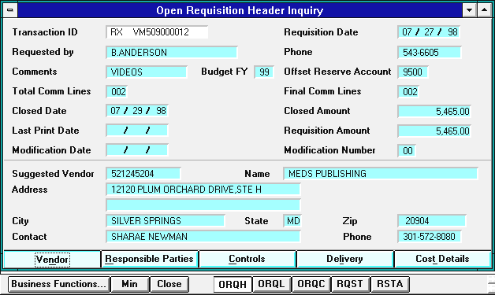
The Responsible Parties View shows name of the person from the user department who is responsible for this order as well as the agency/org being charged.
The Controls View shows internal Advantage control information. This view is seldom used.
The Delivery View contains the requested delivery date and location information.
The Cost Details View shows the discount code and amount, freight amount, and tax code information for this order.
To switch to a different view, click on that button at the bottom of the ORQH window, e.g., to view the discount and freight amounts of this order:
- Click on:

Open Requisition Header Inquiry (ORQH)
The RX document header will appear on your screen in the Cost Details View.
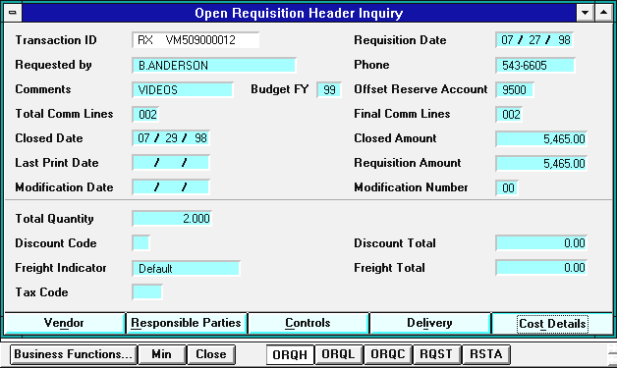

To view the next RX on the ORQH:
 | Toolbar | Key | Menubar
- Click on: |  | F5 | DISPLAY: MORE DATA

OR
To access the accounting line information for this RX:
- Click on the |  | button at the bottom of the screen.

Open Requisition Account Line Inquiry (ORQL)
The accounting line information from the Open Requisition Account Line Inquiry table (ORQL) will appear on your screen. The ORQL window is smaller than the ORQH window so you may wish to maximize the active ORQL window (see page 6 for directions on maximizing).
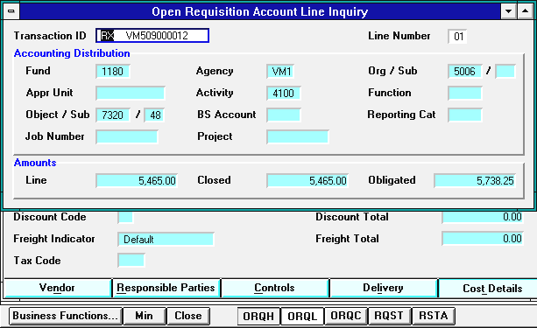

To view the next accounting line for this RX on the ORQL:
 | Toolbar | Key | Menubar
- Click on: |  | F5 | DISPLAY: MORE DATA

OR
To access the commodity line information for this RX:
- Click on the |  | button at the bottom of the screen.

Open Requisition Commodity Line Inquiry (ORQC)
The commodity line information from the Open Requisition Commodity Line Inquiry table (ORQC) will appear. The ORQC window is also smaller than the ORQH window so you may wish to maximize the active ORQC window.
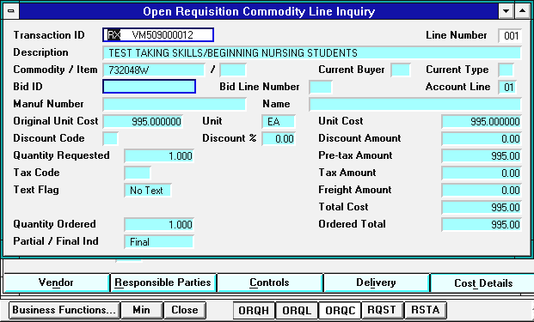

To view the next commodity line for this RX on the ORQC:
 | Toolbar | Key | Menubar
- Click on: |  | F5 | DISPLAY: MORE DATA

OR
To access Requisition Status information for this RX from the RQST:
- Click on the |  | button at the bottom of the screen.

Requisition Status Inquiry (RQST)
The Requisition Status Inquiry table (RQST) will appear with the RX document ID from the ORQC in the Transaction ID field. The RQST table shows accepted RX documents by commodity line and the Purchase Orders that have been created out of them by Document ID Number.
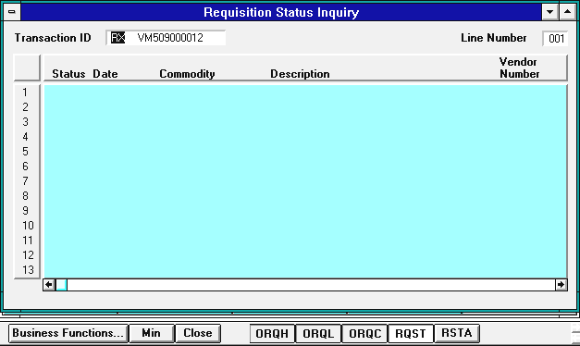
To view the Requisition Status of this commodity line:
 | Toolbar | Key | Menubar
- Click on: |  | F4 | DISPLAY: BROWSE DATA

Requisition Status Inquiry (RQST)
The information relating to that commodity line will be displayed on your screen. An explanation of the status codes is shown on the RSTA table (see next page).
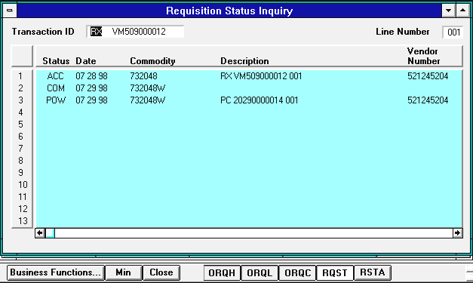
To view information on the next commodity line of this RX, or to view the next RX on this table:
 | Toolbar | Key | Menubar
- Click on: |  | F5 | DISPLAY: MORE DATA

OR
To access Requisition Status Code information from the RSTA:
- Click on the |  | button at the bottom of the screen.

Requisition Status Code Table (RSTA)
The Requisition Status Code table (RSTA) will appear. The RSTA table is a listing of the Status Codes used in the STATUS field on the RQST table, and their descriptions.
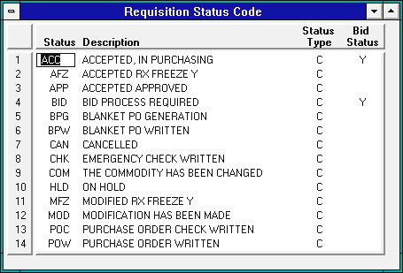
To view the second page of status codes:
 | Toolbar | Key | Menubar
- Click on: |  | F5 | DISPLAY: MORE DATA

Looking Up SR Documents

To view the Open Tables for Stock Requisition (SR) documents by Document ID Number:
- Click on the |  | button.

Open Stock Requisition Header Inquiry (OSRH)
The Open Stock Requisition Header Inquiry table (OSRH) will appear. The OSRH table allows you to view the Header information from SR documents by Document ID Number.
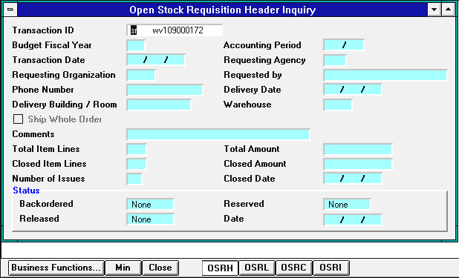

- Type SR and the DOCUMENT ID NUMBER in the TRANSACTION ID field.
 | Toolbar | Key | Menubar
- Click on: |  | F4 | DISPLAY: BROWSE DATA

Open Stock Requisition Header Inquiry (OSRH)
The SR document header will appear on your screen.
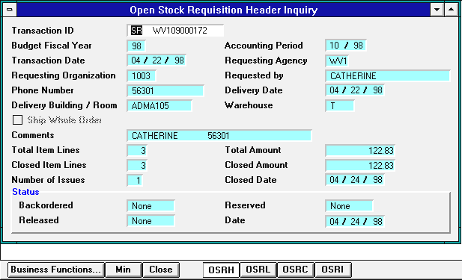

To view the next SR document on the OSRH:
 | Toolbar | Key | Menubar
- Click on: |  | F5 | DISPLAY: MORE DATA

OR
To access the accounting line information for this SR:
- Click on the |  | button at the bottom of the screen.

Open Stock Requisition Account Line Inquiry (OSRL)
The accounting line information from the Open Stock Requisition Account Line Inquiry table (OSRL) will appear. The OSRL window is smaller than the OSRH window so you may wish to maximize the active OSRL window (see page 6 for directions on maximizing).
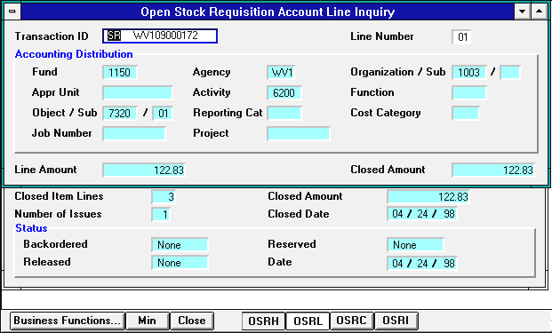

To view the next accounting line of this SR on the OSRL:
 | Toolbar | Key | Menubar
- Click on: |  | F5 | DISPLAY: MORE DATA

OR
To access the commodity line information for this SR:
- Click on the |  | button at the bottom of the screen.

Open Stock Requisition Commodity Line Inquiry (OSRC)
The commodity line information from the Open Stock Requisition Line Inquiry table (OSRC) will appear. The OSRC window is also smaller than the OSRH window, so you may wish to maximize the active OSRC window.
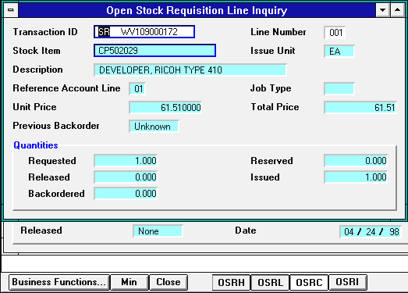

To view information on the next commodity line of this SR on the OSRC:
 | Toolbar | Key | Menubar
- Click on: |  | F5 | DISPLAY: MORE DATA

OR
To access information on the status of released and issued items on this commodity line from the OSRI table:
- Click on the |  | button at the bottom of the screen.

Open Stock Requisition Item Issues Inquiry (OSRI)
The Open Stock Requisition Item Issues Inquiry table (OSRI) will appear. This table shows which items have been released and issued on the order for each commodity line of your order.
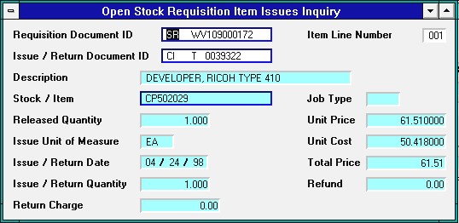

To view the next commodity line for this SR or to view the next SR on OSRI:
 | Toolbar | Key | Menubar
- Click on: |  | F5 | DISPLAY: MORE DATA

Looking Up VI Documents
To view the Open Tables for Vendor Invoice (VI) documents:
- Click on the |  | button.

Open Vendor Invoice Header Inquiry (OVIH)
The Open Vendor Invoice Header Inquiry table (OVIH) will appear. The OVIH table allows you to view the Header information of Vendor Invoice (VI) documents by the Vendor Code and VI Document ID.
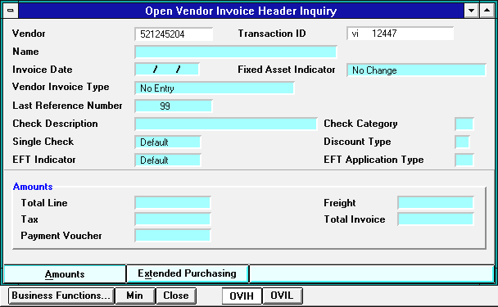

- Type the VENDOR CODE in the VENDOR field, e.g., 521245204. (If there is a suffix, type the VENDOR CODE, one space, and then the Suffix, e.g., 133326802 p.)
- Type VI and the VENDOR INVOICE NUMBER in the TRANSACTION ID field, e.g., vi 12447.
 | Toolbar | Key | Menubar
- Click on: |  | F4 | DISPLAY: BROWSE DATA

Open Vendor Invoice Header Inquiry (OVIH)
The VI document header information will appear in the Amounts View. The Amounts View shows the Total Line, Tax, and Freight amounts on this invoice beneath the VI Header information.
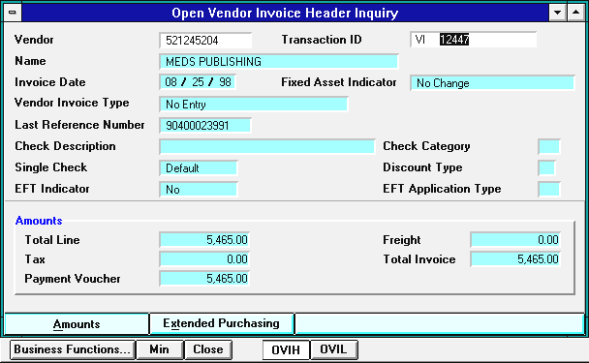

To view the next VI document in the Amounts View on the OVIH:
 | Toolbar | Key | Menubar
- Click on: |  | F5 | DISPLAY: MORE DATA

OR
To view Discount amounts, the closed date, and other information for the header of this invoice:
- Click on:

Open Vendor Invoice Header Inquiry (OVIH)
The VI document header information will appear in the Extended Purchasing View. The Extended Purchasing View shows the Discount, Tax, and Freight amounts on this invoice beneath the VI Header information.
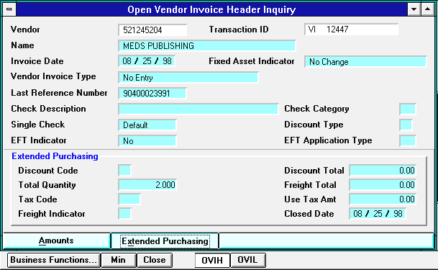
To view the next VI document in the Extended Purchasing View on the OVIH:
 | Toolbar | Key | Menubar
- Click on: |  | F5 | DISPLAY: MORE DATA

OR
To access information for the lines of this VI on the OVIL table:
- Click on the |  | button at the bottom of the screen.

Open Vendor Invoice Line Inquiry (OVIL)
The line information from the Open Vendor Invoice Line Inquiry table (OVIL) will appear.
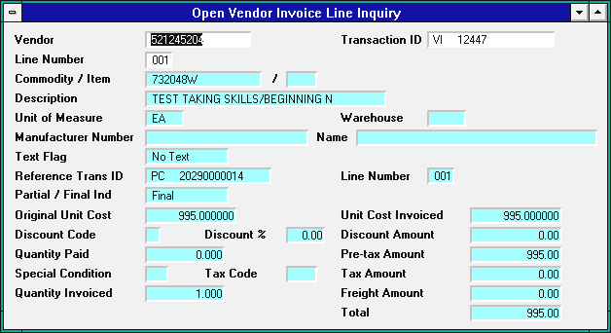

To view information for the next line of this VI on the OVIL table:
 | Toolbar | Key | Menubar
- Click on: |  | F5 | DISPLAY: MORE DATA

Looking Up Check Status
To view the Open Tables for Check Status information:
- Click on the |  | button.

Open Check Header Inquiry (OPCH)
The Open Check Header Inquiry table (OPCH) will appear. The OPCH table allows you to view Header information from AD and MW documents by Document ID Number. This table also shows whether or not a particular check has cleared the bank according to the latest bank interface.
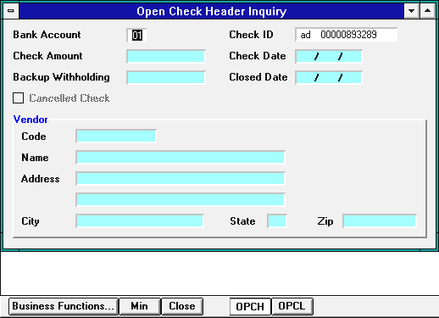

- Type 01 in the BANK ACCOUNT field.
- Type AD and the CHECK NUMBER (e.g., ad 00000893289) in the CHECK ID field.
 | Toolbar | Key | Menubar
- Click on: |  | F4 | DISPLAY: BROWSE DATA

Open Check Header Inquiry (OPCH)
The requested check header information will appear.
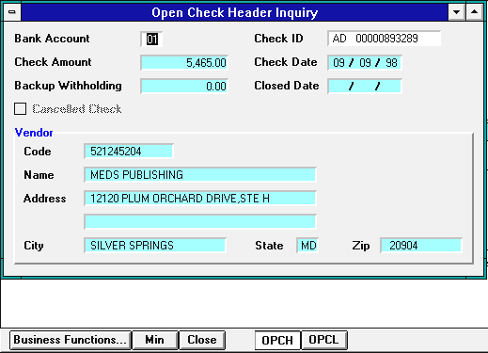

- The CLOSED DATE field indicates the date the check cleared the bank. The check shown in the above example has not cleared the bank.

To view the next check on the OPCH:
 | Toolbar | Key | Menubar
- Click on: |  | F5 | DISPLAY: MORE DATA

OR
To access information for the lines of this check:
- Click on the |  | button at the bottom of the screen.

Open Check Line Inquiry (OPCL)
The line information from the OPCL for this check will appear on your screen.
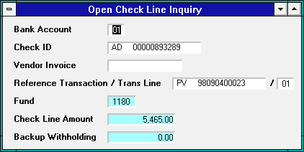

To view the next transaction line on this check, or to view the next check on the OPCL:
 | Toolbar | Key | Menubar
- Click on: |  | F5 | DISPLAY: MORE DATA

The Document History Tables
To access the Document History Tables:
- Click on the |  | button.

Document Cross-Reference Inquiry (DXRF)
The Document Cross-Reference Table (DXRF) will appear. The DXRF table is a system-maintained table containing reference information about Advantage documents.
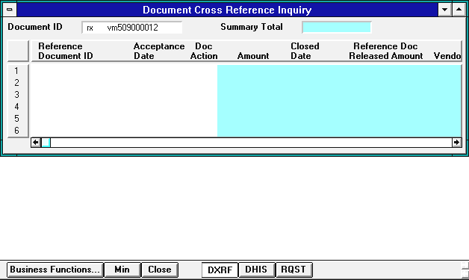

- Type the DOCUMENT TRANSACTION TYPE and the DOCUMENT ID NUMBER (e.g., rx vm509000012) in the DOCUMENT ID field.
 | Toolbar | Key | Menubar
- Click on: |  | F4 | DISPLAY: BROWSE DATA

Document Cross-Reference Inquiry (DXRF)
The information related to the requested document will appear.
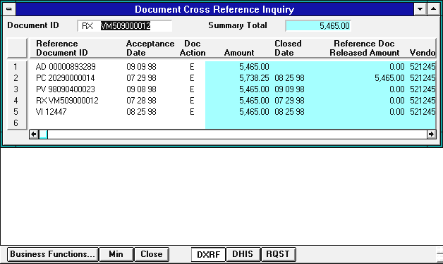
To view the next document on the DXRF:
 | Toolbar | Key | Menubar
- Click on: |  | F5 | DISPLAY: MORE DATA

OR
To access additional history information for this document on the DHIS:
- Click on the |  | button at the bottom of the screen.

Document History Inquiry (DHIS)
The Document History Inquiry Table (DHIS) will appear. The DHIS is a system-maintained table containing accounting reference information about Advantage documents.
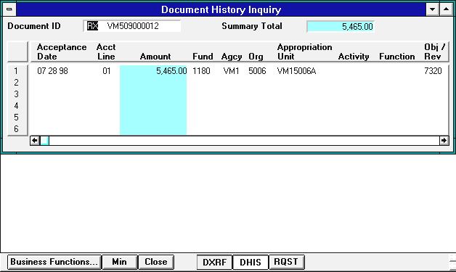
To view the next document on the DHIS:
 | Toolbar | Key | Menubar
- Click on: |  | F5 | DISPLAY: MORE DATA

OR, IF YOU ARE VIEWING AN RX DOCUMENT,
To access additional history information for this document on the RQST:
- Click on the |  | button at the bottom of the screen.

Requisition Status Inquiry (RQST)
The Requisition Status Inquiry table (RQST) will appear with the RX document ID from the DHIS in the Transaction ID field. The RQST table shows accepted RX documents by commodity line and the Purchase Orders that have been created out of them by Document ID Number.
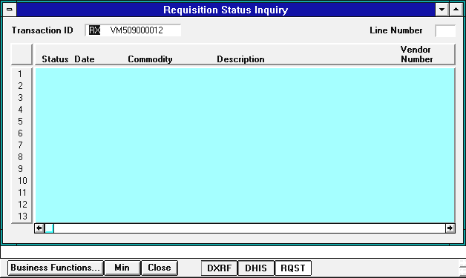
To view the Requisition Status of this commodity line:
 | Toolbar | Key | Menubar
- Click on: |  | F4 | DISPLAY: BROWSE DATA

Requisition Status Inquiry (RQST)
The information relating to that commodity line will be displayed on your screen. An explanation of the status codes is shown on the RSTA table (see page 53).
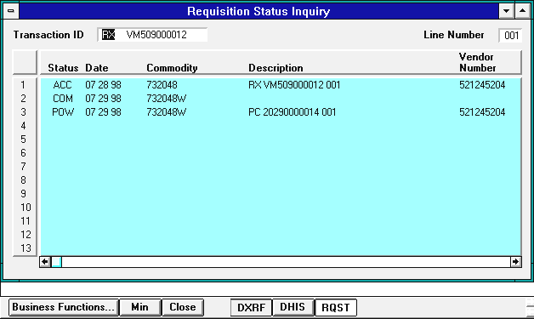
To view information on the next commodity line of this RX, or to view the next RX on this table:
 | Toolbar | Key | Menubar
- Click on: |  | F5 | DISPLAY: MORE DATA

