ADVANTAGE
Transfer Documents

Distributed by
Financial Services
Arizona State University
May 10, 2006

Transfer Documents
Types of Documents | There are four on-line documents that permit various types of funding, budgeting, and expense transfers. They are the Appropriation Transfer (A1), the Expense Transfer (IX), the Transfer Voucher (TV), and the Journal Voucher (J1). Each of these documents is presented as a separate topic.
Overall Processing | Overall processing of the four documents follows the same pattern as detailed below. User departments and accountants in Financial Services or grant administrators in the Office of Research and Sponsored Projects Administration (ORSPA) complete specific steps in preparing, approving, and processing the on-line funding, budget, and expense transfer documents.
Approval Levels Required | Transfer documents require Level 1 approval by the org manager or authorized signer for the particular agency org. All transfer documents also require approvals at Levels 4 and 5 by the appropriate account in Financial Services for non-sponsored accounts and by grant administrators in ORSPA for sponsored accounts.  Backup documentation supporting the entry should be forwarded to the grant administrator for all IX and J1 documents on sponsored agency orgs. Sponsored agency orgs cannot use either the A1 or the TV document. Financial Services may require some documentation for non-sponsored agency orgs.
 | Document Processing Responsibilities
Responsibility of | Action to be taken
Requesting Department | Determines which document to use: A1, IX, TV, J1.  Verifies the account information  agency org, sub-org  object/sub-object codes  function category  revenue/sub-revenue code.  Verifies that the funding balances and/or expenses are available for transfer.  Chooses the correct document.  Prepares the document.  Reviews the document for accuracy and completness.  Approves the document at Level 1.  Closes the window.  Forwards any required documentation to the appropriate accountant in Financial Services or the appropriate grant administrator in ORSPA.
Accountant or Grant Administrator | Retrieves the document from the Suspense file.  Reviews the document for accuracy, completeness, and appropriateness.  Approves and processes the document.

 | A1 Document - Appropriations Transfer
Appropriation Transfer  (A1) | An Appropriation Transfer Document or A1 is an on-line document used to transfer non-sponsored appropriation budgets from one agency org to another agency org, e.g., CK1 1001 to WV1 1004, or from one appropriation category to another, e.g., CK1 1001P to CK1 1001A (transfer of State Personal Services from Vacancy Savings to State All Other Operating category).
Guidelines:
State Account Transfers | A1 documents permit transfer of appropriation budgets between state agency orgs, for example to transfer from one state account to another due to reorganization: TR1 1001 to WV1 1004.
Vacancy Savings | A1 documents permit transfer between appropriation categories within the same local budgeted agency org, e.g., to transfer Personal Services vacancy savings to the All Other Operating Expense category TR1 1001P to TR1 1001A.
Restrictions | Users process A1 documents only on non-sponsored budgeted agency orgs and they are the only document used to transfer state budget appropriations. A1 documents are not allowed on any Cash Basis accounts. State Appropriations can only be transferred among agency orgs on the same campus, i.e., they do not permit the transfer of state appropriations between Main, West, and East campus agency orgs.  Appropriation transfers (A1 documents) are processed in like units only, i.e., from one state agency org to another state agency org but not from a state agency org to a local agency org. On local budgeted accounts, appropriation transfers can be processed only between different appropriation categories within the same agency org. (A transfer from WV51014P to WV51014E is allowed but a transfer from WV5 1014 to WV5 1010 is not permitted.)  Net increases must equal net decreases and the total transfer-in amount must equal the total transfer-out amount.
Special Approval | For additional information reference Financial Services COM Policy 102-01.
Example | The Music Department wants to use $6450 in salary savings that has accrued from a vacancy to pay for needed goods and services. The position line number is 49876 (for employee 993856472) on agency org TR1 1001 and appropriation unit P (personal services). The entire amount is to be moved to appropriation unit A (all other operating expenses) on the same agency org.

The following information should be gathered prior to beginning the A1 document
- Information related to the date, fiscal year, and accounting period, if they are different from the current date and accounting period.
- Valid agency, org, and appropriation unit for the account to be decreased (the account from which the budget amount is to be taken, for example, TR1 1001P.
- The amount of the decrease in dollars only. Appropriations do not allow cents as part of the amount.
- Appropriate wording for the description OR for personal services lines: position number, employee id, and the effective date to be entered in appropriate fields, for example, 49876, 993856472, 010104
- Valid agency, org, and appropriation unit for the account to be increased (the account into which the budget amount is to be moved, for example, TR1 1001A.
- Appropriate wording for the description, for example, VACSAV.

Starting an A1 Document from the Business Functions Window
To begin an A1, click on:   | 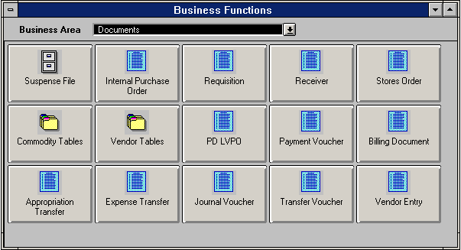
A blank Document Entry Window appears.  Verify that the Document Type is correct, e.g., Appropriation for an A1 document.  Tab to Document ID. | 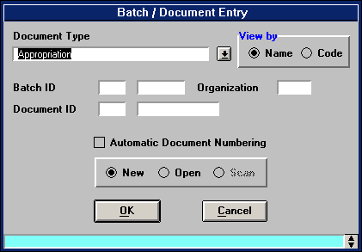
Type the three-character agency (TR1) in the first box after Document ID.  This is the agency of the account not benefiting from the transfer or the A1 account from which the transfer is to be made.  Type the three-character agency again followed by the # (TR1#) in the second box after Document ID.  Click on Automatic Document Numbering.  Ensure that New is marked. (If not, click the New button). | 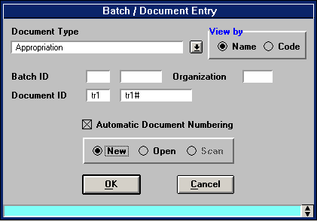

Click on the OK button: | 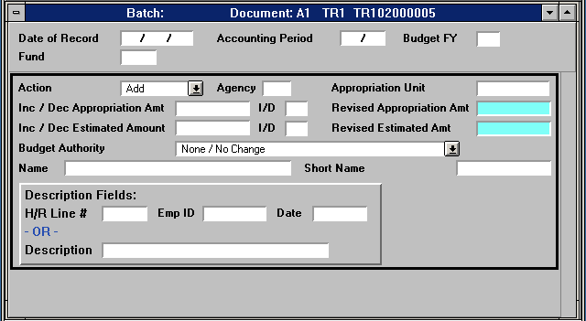  

Completing an A1 Document
A blank A1 document appears.
Verify that the agency is correct and that the document ID is complete.
Fill in the blank A1 according to the following examples and instructions.
Complete only the fields indicated.

Enter data in the following fields only (bolded fields are required):
Date of Record | Leave blank. The system will generate during processing.
Accounting Period | Optional. If left blank, defaults to the accounting period associated with the transaction date.
Budget FY | Type the current fiscal year (e.g., 04 for fiscal year 2003-2004).
Fund | Type the appropriate fund for the agency.
Action | Using the drop-down menu, select Modify.
Agency | Type the agency from which the money is being transferred.
Appropriation Unit | Type a valid appropriation unit as defined by the Appropriation (APPR) table from which the money is being transferred.
Inc/Dec Appropriation Amt | Type the amount of the transfer-out (no decimal or cents).
I/D | Type D for decrease.
Description Fields | When transferring Personal services savings, use the H/R fields: type the Line #, the Employee ID, and the Start Date in the appropriate fields e.g., 49876, 993856742, 010104, otherwise type an appropriate description
The first A1 screen should look like this. | 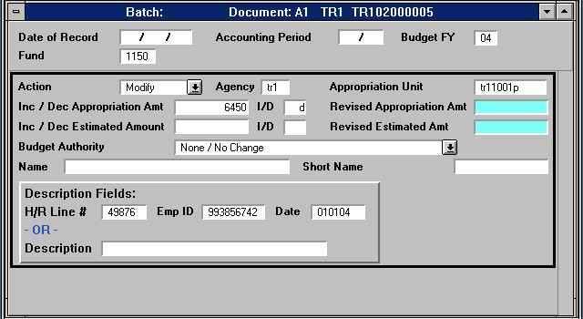

Click the insert line icon |  | to insert a line and continue this document.

Completing an A1 Document
The second screen of the A1 document appears.  Fill in the blank A1 screen for the transfer in portion of the A1 according to the following examples and instructions. Complete only the fields indicated. | 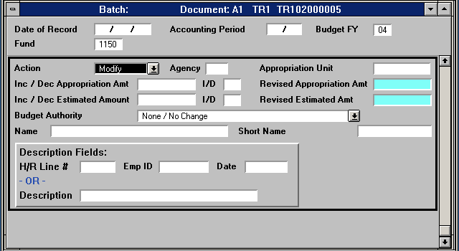

Action | Using the drop-down menu, select Modify.
Agency | Type the agency into which the money is being transferred.
Appropriation Unit | Type a valid appropriation unit, as defined by the Appropriation (APPR) table, into which the money is being transferred.
Increase/Decrease Appropriation Amt | Type the amount of the transfer-in (no decimal or cents).
I/D | Type I for increase.
Description Fields | When transferring Personal Services, type VACSAV in the description; otherwise type an appropriate description for the increase.
The completed A1 screen should look like this. | 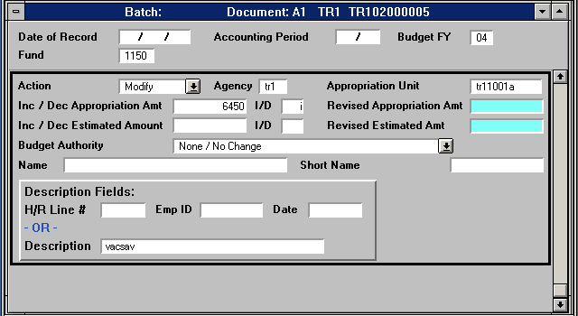
Note: A1 documents should be approved at Level 1 and the window closed. Financial Services Accountant approvals are required at Levels 4 and 5. Therefore, the A1 will remain in the Suspense File until all approval levels are applied and final processing occurs.

TV Document – Transfer Voucher
Transfer Voucher (TV)  Examples: | A Transfer Voucher or TV is an on-line document that allows voluntary funding transfers for certain categories of accounts to be made from one agency org to another within the same fund group or between different fund groups.  To process budgeted transfers-in or transfers-out.  To move funds to support a specific project or program.  To move the residual balance of an inactive account so that it may be closed.  To fund another account for a specific purchase.
Guidelines | Transfer Vouchers are allowed on:  Budgeted Local Accounts  Cash Basis Local Accounts  Auxiliary Accounts  Local or Auxiliary Accounts between campuses.
Fund Groups | Fund Group codes can be found on the FUN2 table using the Go To Window.
Same Fund Group | For transfers between agency orgs within the same fund group, e.g., between TR5 1029 and TR5 1006, the transfer in or Revenue Source and Sub Rev Code is 6001 10 and the Object Sub Object Code is 8001 10.
Different Fund Groups | For transfers between agency orgs in different fund groups, e.g., between ET5 1006 and EV2 1002, the transfer in or Revenue Source and Sub Rev Code is 6001 20 and the Object Sub Object Code is 8001 20.
Capital Equipment | When transferring funding for the purchase of Capital Equipment - Object Codes 7810 or 7890, a TV may be used if the purchase is to remain with the original account, BUT if the property is to be retained by another account, an Expense Transfer (IX) document must be used instead.
Restrictions | Transfers Vouchers cannot be used on:  State Accounts  Sponsored Accounts  Agency Accounts  Summer Session Accounts
Example | The Music Department wants to transfer $634.00 from the Ethnic Music Ensemble's account TR5 1006 to the Steel Drum's account TR5 1029 to support a special event.

The following information should be gathered prior to beginning the TV document
Information related to the date, fiscal year, and accounting period, if it is different from the current date and accounting period.
Valid agency, org and suborg, if applicable, for the account to be decreased (the account from which the fund amount is to be taken). TR5 1006
The amount of the decrease in dollars and cents. $634.00
Valid agency, org, and sub org, if applicable, for the account to be increased (the account into which the fund amount is to be moved). TR5 1029
Appropriate wording for the description, e.g., support special event.

Completing a TV Document
To begin a TV, click on the Transfer Voucher button in the last row.

A blank Document Entry Window appears.  Verify that the Document Type is correct, e.g., Transfer Voucher for a TV document.  Tab to Document ID. | 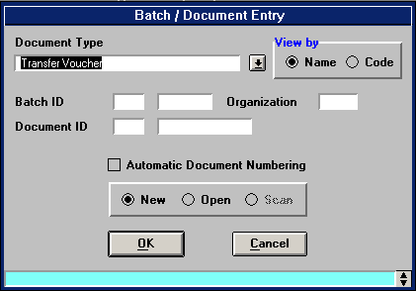
Type the three-character agency (TR5) in the first box after Document ID.  This is the agency of the account not benefiting from the transfer or the TV account from which the transfer out is to be made.  Type the three-character (TR5) agency again followed by TV# in the second box after Document ID.  Click on Automatic Document Numbering.  Ensure that New is marked. (If not, click the New button). | 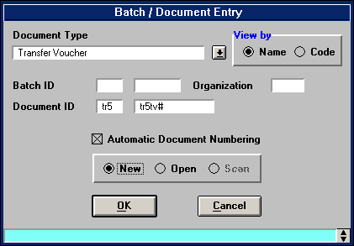
Click on the OK button:

Completing a TV Document
A blank TV document appears.  Verify that the agency is correct and that the document ID is complete.  Fill in the blank TV document that appears according to the following examples and instructions.  Complete only the fields indicated. |  | 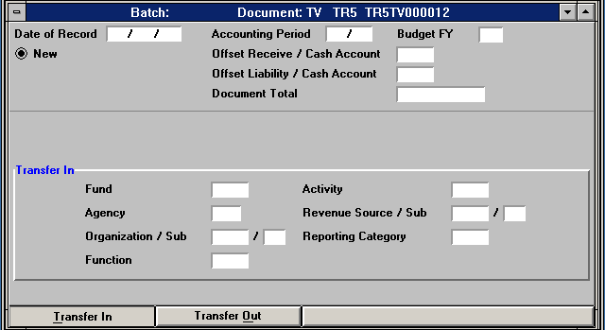
Enter data in the following fields only (bolded fields are required):
Date of Record |  | Leave blank. The system will generate during processing.
Accounting Period |  | Optional. If left blank, defaults to the accounting period associated with the transaction date.
Budget FY |  | Optional. If left blank, defaults to the current budget fiscal year. Enter a different fiscal year (e.g., 05 for fiscal year 2004 - 2005 or MY for multi-year budgets [used for sponsored agency orgs]).
Document Total |  | Type the total amount being transferred (including two decimal places).
Agency |  | Type the agency into which the funds are being transferred.
Org |  | Type the org into which the funds are being transferred.
Suborg |  | If applicable, type the suborg into which the funds are being transferred.
Function |  | Type the three digits of the agency and last digit of the org that is being debited, i.e., the account from which the funds are being transferred.
Rev Source |  | Type 6001.
Sub Rev |  | Type 10 for transfers within the same fund group or  Type 20 for transfers between different fund groups.
The completed screen should look like this. |  | 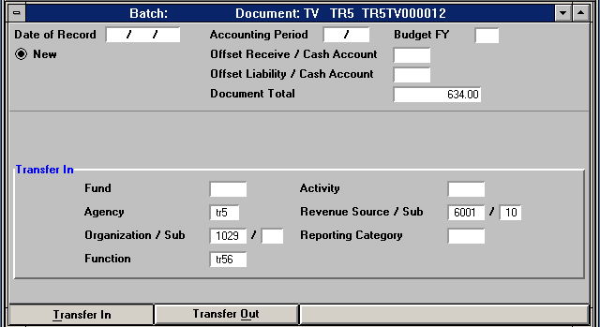
Click on: |  |  | to go to the Transfer Out View of the TV Document.

Completing a TV Document
The transfer section of the TV document appears.  Fill in the blank TV screen for the transfer in portion of the TV according to the following examples and instructions.  Complete only the fields indicated. | 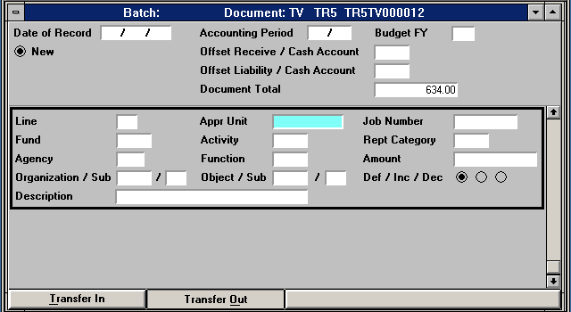
Enter data in the following fields only (bolded fields are required):
Line | Type the number to distinguish this transfer line from all others on this document. Start with 01.
Agency | Type the agency from which the funds are being transferred.
Org | Type the org from which the funds are being transferred.
Suborg | If applicable, type the suborg from which the funds are being transferred.
Function | Type the three digits of the agency and last digit of the org that is being credited, i.e., the account into which the funds are being transferred.
Object | Type 8001.
Subobject | Type 10 for transfers within the same fund group or  Type 20 for transfers between different fund groups.
Amount | Type the amount of funds being transferred on this line, including two decimal places for cents.
Description | Type an appropriate description of why funds are being transferred.  If transferring Capital Equipment - object codes 7810 or 7890, the original PC, PO, or SC number must begin the description in the format of: document type, followed by a space and then the document number (PC 30204M00028).
The completed TV screen should look like this. | 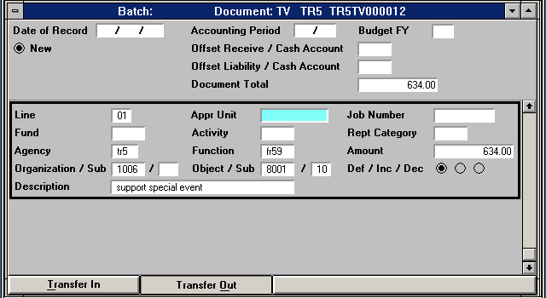
Note: Documents should be approved and the window closed. Financial Services Accountant approvals are required at Levels 4 and 5, therefore, the TV will remain in the Suspense File until all approval levels are applied and final processing occurs.

IX - Expense Transfer Document
Expense Transfer (IX) | An Expense Transfer Document or IX is an on-line document that permits expenditure transfers between one account or agency org and another, e.g., from TR1 1001 to BGM 8008. IX documents also permit the correction of miscoded account code information, such as an object subobject code, suborg, or function.
Examples: | To correct an object subobject code: An expense coded to office supplies (7320 01) should have been coded to software (7320 48).  To correct an incorrect agency org: WV1 1001 to WV1 1004.  To correct an expense which should have been coded to a suborg: from TR5 1008 to TR5 1008 CA.
Guidelines: | IX documents permit expense transfers on sponsored and non-sponsored agency orgs and between different campuses (Main, West, and East) with some exceptions.
Object Code Limitations | Expense Transfers cannot be made on the following object codes:
 | 7100 | Budgeted Salaries
 | 7120 | Wages
 | 7200 | Payroll-related Expenses
 | 7900 | Administrative Service Charges
 | 8001 | Transfers Out
 | When transferring capital equipment (object codes 7810 or 7890) remember to begin the description with the purchase order type (PC, PO, or SC) followed by a space and then the purchase order number and send a copy of the IX to Property Accounting.
Other Limitations | The IX is used for one-to-one expense transfers only. For a one-to-many transfer, the J1 is required. Expense transfers cannot be made to agency orgs when the expenditures are not allowable, e.g., food and drink on some accounts.
Example | The Music Department needs to transfer $330.00 in copying charges from state account TR1 1001 to the Guest Services sponsored projects account BGM 8008.

The following information should be gathered prior to beginning the IX document
Information related to the date, fiscal year, and accounting period, if it is different from the current date and accounting period.
Valid agency, org, and sub org and/or function, if applicable, for the account from which (seller) the expense is to be transferred. TR1 1001
The amount of the expense transfer in dollars and cents. $330.00
Valid agency, org, and sub org and/or function, if applicable, for the account into which (buyer) the expense is to be transferred. BGM 8008.
The buyer is the one not benefiting from the transfer because they are "buying the expense" so this agency must be used to begin the document number on the data entry screen.
Appropriate wording for the description, e.g., copying charges recital program.

Completing an IX Document
To begin an IX, click on the Expense Transfer button in the last row.

A blank IX document appears.  Verify that the Document Type is correct, e.g., Expense Transfer for an IX document.  Tab to Document ID. | 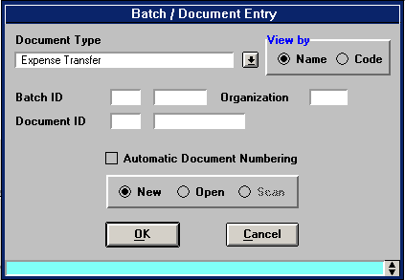
Type the three-character agency of the account that is not benefiting from this transfer (e.g., BGM) in the first box after Document ID. BGM is not benefiting because they are in effect buying the expense.  Type the three-character agency again followed by IX# in the second box after Document ID.  Click on Automatic Document Numbering.  Ensure that New is marked. (If not, click the New button). | 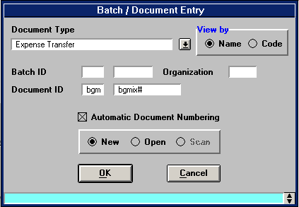
Click on the OK button:

Completing an IX Document
The seller view of the IX document appears.  Fill in the appropriate fields on the blank IX screen for account information from which the expense is being transferred according to the following examples and instructions. Complete only the fields indicated.  Bolded fields are required |  | 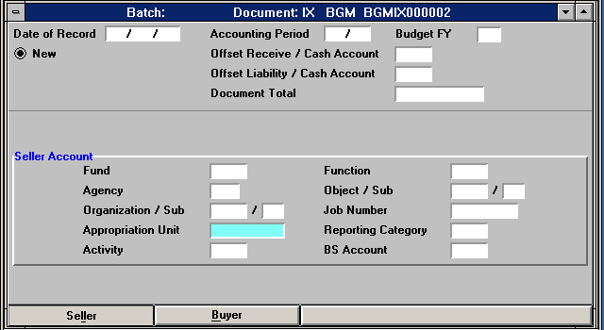
Date of Record |  | Leave blank. The system will generate during processing.
Accounting Period |  | Optional. If left blank, defaults to the accounting period associated with the transaction date.
Budget FY |  | Optional. If left blank, defaults to the current budget fiscal year. Enter the current fiscal year (e.g., 04 for fiscal year 2004 or MY for multi-year budgets that are used for sponsored agency orgs).
Document Total |  | Type the total amount of expenses being transferred out.
Agency |  | Type the agency from which the expense is being transferred.
Organization |  | Type the organization from which the expense is being transferred.
Suborg |  | If applicable, the suborg from which the expense is being transferred.
Function |  | If applicable, type the function code related to the account from which the expense is being transferred.
Object |  | Type the object code from which the expense is being transferred.
Subobject |  | Type the object code from which the expense is being transferred
The completed IX screen should look like this. |  | 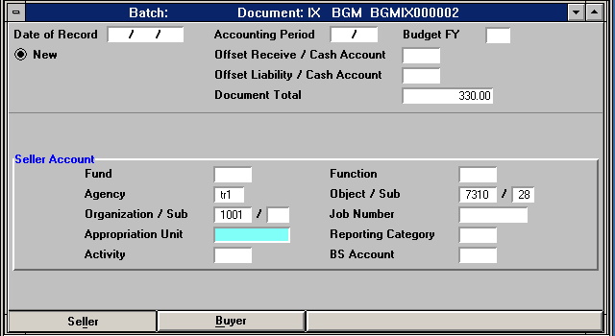
Click on: | Buyer | to go to the Buyer View of the IX Document.

Completing an IX Document
The buyer view of the IX document appears.  Fill in appropriate fields for the buyer view of the IX according to the following examples and instructions.  Complete only the fields indicated and appropriate for your expense transfer.  Bolded fields are required. | 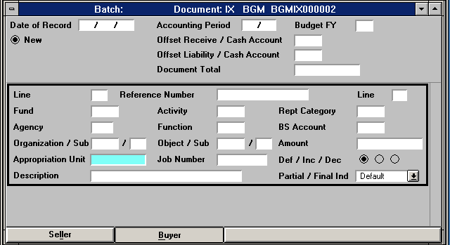

 | Line | Begin with 01.
 | Agency | Type the agency into which the expense is being transferred.
 | Function | If applicable, type the function into which the expense being transferred.
 | Organization | Type the organization into which the expense is being transferred.
 | Suborg | If applicable, type the suborg into which the expense is being transferred.
 | Object | Type the object code into which the expense is being transferred.
 | Subobject | Type the subobject code into which the expense is being transferred.
 | Amount | Type the amount of expense that is being transferred into this account
 | Description | Type an explanation for the expense transfer.
The completed IX document should look like this. |  | 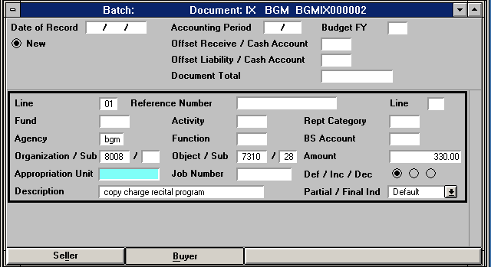

Note: Documents should be approved and the window closed. Financial Services Accountant approvals are required at Levels 4 and 5 for non-sponsored agency orgs and grant administrator approvals are required at Levels 4 and 5 for sponsored agency orgs.

Therefore, the IX will remain in the Suspense File until all approval levels are applied and final processing occurs.

J1 – Journal Voucher within the Same Fund
Journal Voucher  (J1) | A Journal Voucher or J1 is a versatile and powerful on-line document that performs the same features of the IX and TV documents, as well as its own unique capabilities.
Guidelines | J1 documents must be used to correct revenue or when cash is involved in a transfer of property, etc.  J1documents are used in situations where the IX document is inappropriate, e.g., when expenses are being transferred from multiple agency orgs to one agency org, or when the expense was created on a restricted object/sub-object code (see listing on page 8).  J1 documents are also used when the TV document is inappropriate, e.g., when certain agency orgs such as Sponsored accounts are involved or when the activity involves transferring funds into multiple agencies.  J1 documents may be used to transfer revenue (on non-state accounts) and expense entries between the different ASU campuses (Main, West, and East).
Revenue Corrections | J1 documents are used for revenue corrections: to correct revenue source codes miscoded information on a Cash Receipts Deposit, and account code information on multiple accounts at the same time.
Non-Service Departments | J1 documents are used to pay agency orgs that are not designated as Service Departments; a department offers a special training class for a fee, such as General Counsel's Law for Administrators.
Service Departments | J1 documents are used by designated Service Departments to reverse processed II billing charges when a department returns goods to ASU Stores for credit or when an agency org was billed in error.
Limitations | Revenue cannot be recognized on state area/orgs.
Example | Revenue amounting to $220 from the performance of H.M.S. Pinafore will be moved from the Lyric Opera Theatre account TR5 1013 to suborg HP for that account (TR5 1013).

The following information is based on the above example. Such information should be gathered prior to beginning the J1 document. In this example TR5 1013 revenue is debited and TR5 1013 suborg HP receives a credit for $220. Since the suborg is receiving revenue, the TR5 1013 with no sub org is the account not benefiting from the transfer or revenue. TR5 is used to begin the document.
Information related to the date, fiscal year, and accounting period, if it is different from the current date and accounting period.
Valid agency, org, and suborg for the account to be decreased (the account from which the revenue is to be taken or debited). TR5 1013
The amount of the decrease in dollars and cents. $220.00
Object subobject or revenue subrevenue codes for the account being debited. 5530 06
Valid agency, org, and suborg, if applicable for the account to be increased (the account into which the fund amount is to be moved). TR5 1013 sub org HP
Appropriate wording for the description, e.g., move revenue to sub org
The amount of the increase in dollars and cents. $220.00
Object subobject or revenue subrevenue codes for the account being credited. 5530 06

J1 – Journal Voucher within the Same Fund
To begin a J1 click on the Journal Voucher button in the last row. | 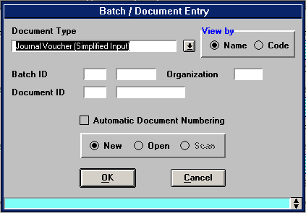
A blank Document Entry Window appears
Verify that the Document Type is correct, e.g., Journal Voucher (Simplified Input) for a J1 document.
Tab to Document ID.

Type the three-character agency (TR5) in the first box after Document ID.  This is the agency of the account not benefiting, e.g., the account whose revenue will be debited.  Type the three-character (TR5) agency again followed by the # in the second box after Document ID.  Click on Automatic Document Numbering.  Ensure that New is marked. (If not, click the New button). | 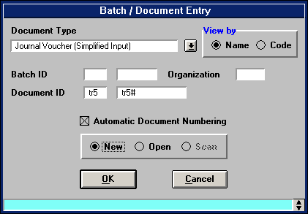
Click on the OK button:

J1 – Journal Voucher within the Same Fund
The first section of the first screen refers to the overall J1 document. Both the debit and credit total amounts must be entered. | 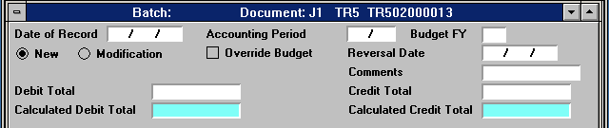
Date of Record | Leave blank. The system will generate during processing.
Accounting Period | Optional. If left blank, defaults to the accounting period associated with the transaction date.
Budget FY | Optional. If left blank, defaults to the budget fiscal year associated with the transaction date.
Action | Ensure that NEW is marked.
Comments | Type appropriate comments per your department.
Debit total | Type the total amount being debited from all debit lines.
Credit total | Type the total amount being credited from all credit lines.
The line portion used for debit or credit lines looks like this.  To use this line for the debit, fill in all the information as indicated. | 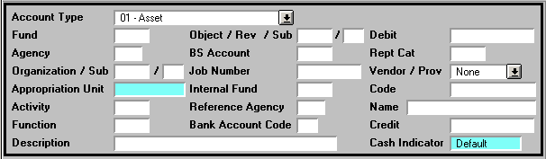
Account Type | Choose the type of account, such as 31 - Revenue from the drop down menu options.
Fund | Leave blank. Advantage will generate during the edit process.
Agency | Type the agency (TR5) that is being debited. (For this example revenue is being lost by TR5 1013 and will be credited to TR5 1013 suborg HP).
Org | Type the organization being debited (1013, f or this example.
Suborg | If applicable, type the suborg being debited.
Function | If applicable, type the function code being debited.
Object or Rev Code | Type the object or revenue code being debited (rev 5530 for this example).
Subobj or Subrev code | Type the subobject code being debited. (subrev 06 for this example).
Debit | Type the debit amount for this line.
Description | Type an appropriate description for the debit including any pertinent information, e.g., reference numbers of documents.
Vendor/Provider | Per departmental procedures.
The completed debit portion looks like this. | 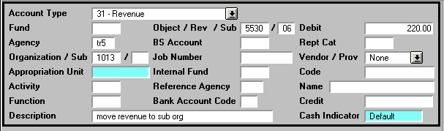
Click the insert line icon |  | to insert a line and continue this document.
J1 – Journal Voucher within the Same Fund
The next line is used for the credit portion of the J1.
Fill in all the information as indicated for the credit line.
Account Type | Choose the type of account, such as 31 - Revenue from the drop down menu options.
Fund | Leave blank. Advantage will generate during the edit process.
Agency | Type the agency (TR5) being credited. (For this example revenue is being gained by TR5 1013 suborg HP).
Org | Type the organization (1013) being credited (e.g., org gaining revenue).
Suborg | If applicable, type the suborg (HP) credited (e.g., suborg gaining revenue).
Function | If applicable, type the function code being credited.
Object or Rev Code | Type the object or revenue code to be credited (5530 for this example).
Subobj or Subrev Code | Type the subobject code or sub revenue code to be credited (06 for this example).
Credit | Type the credit amount for this line.
Description | Type an appropriate description for the credit including any pertinent information, e.g., reference numbers of documents.
Vendor/Provider | Per departmental procedures.
The completed screen with the credit line showing looks like this. | 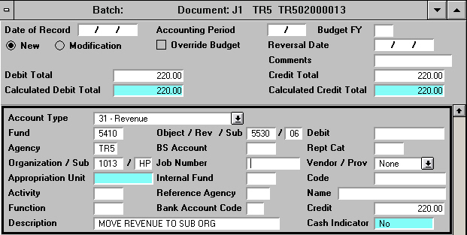

Note: Documents should be approved and then closed. Accountant /Grant Administrator approvals are required at Levels 4 and 5. The J1 will remain in the Suspense File until and final processing occurs.
J1 – Journal Voucher with Different Funds
Journal Voucher – J1 | A Journal Voucher that involves different funds is known as a cross-funds transfer and it requires additional lines called balance sheet lines. Balance sheet lines are required whenever revenue or cash are involved.
Guidelines | J1 documents must be used to correct revenue or cash deposits.  J1 documents are used in situations where the IX document is inappropriate, e.g., when expenses are being transferred from multiple agency orgs to one agency org or from one agency org to many agency orgs.  J1 documents are also used when the TV document is inappropriate, e.g., when certain agency orgs such as sponsored accounts are involved or when the activity involves transferring funds into multiple agencies.  J1 documents may be used to transfer revenue (on non-state accounts) and expense entries between the different ASU campuses (Main, West, and East).
Revenue Corrections | J1 documents are used for revenue corrections: to correct revenue source codes miscoded information on a Cash Receipts Deposit, and account code information on multiple accounts at the same time.
Non-Service Departments | J1 documents are used to pay agency orgs that are not designated as Service Departments; a department offers a special training class for a fee, such as General Counsel's Law for Administrators.
Service Departments | J1 documents are used by designated Service Departments to reverse processed II billing charges when a department returns goods to ASU Stores for credit or when an agency org was billed in error.
Limitations | Revenue cannot be recognized on state area/orgs.
Example | The School of Music and the ASUE Department of Exercise and Wellness collaborated on a 2-day conference called, How Music Heals. The School of Music needs to transfer ASU East's portion of the revenue that amounts to $1,260 from Music account TR5 1008 to the ASUE Wellness account WN5 7001.

The following information should be gathered prior to beginning the J1 document
Information related to the date, fiscal year, and accounting period, if different from the current date and accounting period.
Account type. 31 Revenue
Valid agency, org, and suborg, if applicable, for the account to be debited (where the amount is to be taken from). TR5 1008
The amount of the debit in dollars and cents. $1,260.00
Object or revenue and subobject or sub revenue codes for the account being debited. 5530 15
Description for this line of the JV. Revenue to East How Music
Valid agency, org, and suborg, if applicable, for the account to be credited (the account receiving the revenue). WN5 7001
Appropriate wording for the description, e.g., Revenue from Main How Mus
The amount of the increase in dollars and cents. $1,2600.00
Object and subobject or revenue and subrevenue codes for the account being credited. 5530 15

Account type: 01 Asset
Description for the line: balance sheet transfer
Balance Sheet Account: 1100
Fund for the debit: 5110
Debit Amount: 1,260.00
Fund for the credit: 5160
Credit Amount: 1,260.00
J1 – Journal Voucher with Different Funds (Cross-Funds)
To begin a J1 click on the appropriate button in the last row.

A blank Document Entry Window appears.
Verify that the Document Type is correct, e.g., Journal Voucher (Simplified Input) for a J1 document.
Tab to Document ID.

Type the three-character agency (TR5) in the first box after Document ID.
This is the agency of the account not benefiting, e.g., the account whose revenue will be debited.
Type the three-character (TR5) agency again followed by the # in the second box after Document ID.
Click on Automatic Document Numbering.
Ensure that New is marked. (If not, click the New button).

Click on the OK button:

J1 – Journal Voucher with Different Funds (Cross-Funds)
The first section of the first screen (above the black bordered area) refers to the overall J1 document.  Both the debit and credit total amounts must be entered. On cross-funds transfer the amount will be double the revenue/expense lines (includes the BS lines). | 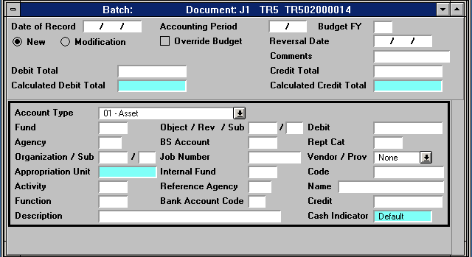
Date of Record | Leave blank. The system will generate during processing.
Accounting Period | Optional. If left blank, defaults to the accounting period associated with the transaction date.
Budget FY | Optional. If left blank, defaults to the budget. Enter the current fiscal year, e.g., 04 for fiscal year 2004 or MY for multi-year budgets (used for sponsored agency orgs).
Action | Ensure that NEW is marked.
Comments | Type appropriate comments per your department.
Debit total | Type the total of all the debit lines including the balance sheet debit line.
Credit total | Type the total of all credit lines including the balance sheet credit line.
The J1 with the total information (in the top section) completed looks like this.  Line information for the debit and credit need to be completed next. | 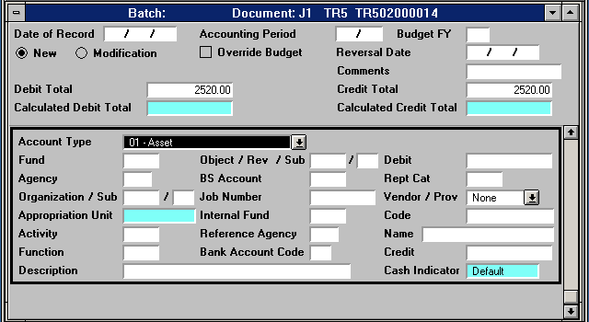

J1 – Journal Voucher with Different Funds (Cross-Funds)
Fill in the debit portion of the J1 according to the following examples and instructions. Complete only the fields indicated.  Bolded fields are required | 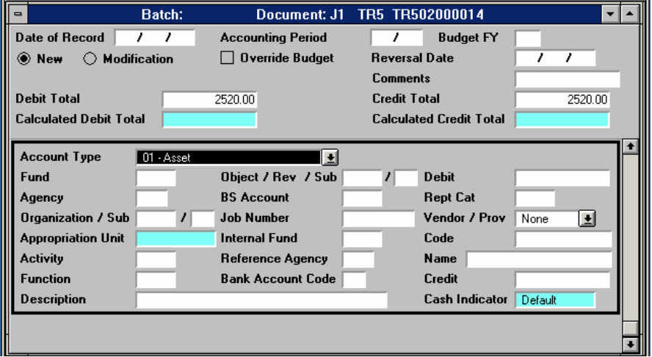
Account Type | Choose the Transaction Type: 22 = Expense/Expenditure 31 = Revenue
Fund | Leave blank. Advantage will generate during the acceptance process.
Agency | Type the agency being debited (TR5 for this example).
Org | Type the organization being debited (1008 in this example).
Suborg | If applicable, type the suborg being debited.
Function | If applicable, type the function being debited.
Object or Rev Code | Type the revenue code being debited (5530 for this example).
Subobj or Subrev Code | Type the sub revenue code being debited (15 for this example).
Debit | Type the debit amount for this line of the J1.
Description | Type an appropriate description including any pertinent information, e.g., document reference numbers.
Vendor/Provider | Per departmental procedures.
The completed screen with the debit line looks like this. | 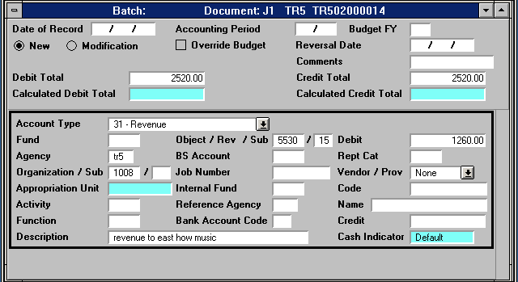

Click the insert line icon |  | to insert a line and continue this document.

J1 – Journal Voucher with Different Funds (Cross-Funds)
The credit side of the J1 document appears.

Fill in the blank J1 screen for the credit portion of the J1 according to the following examples and instructions. Complete only the fields indicated.

Bolded fields are required

Account Type | Choose the Transaction Type: 22 = Expense/Expenditure 31 = Revenue
Fund | Leave blank. Advantage will generate during the edit process.
Agency | Type the agency to be credited (WN5 for this example).
Org | Type the organization to be credited (7001 for this example).
Suborg | If applicable, type the suborg to be credited.
Function | If applicable, type function to be credited.
Object or Rev code | Type the object or revenue code to be credited (5530 for this example).
Subobj or Subrev code | Type the subobject code or sub revenue code to be credited (15 for this example).
Credit | Type the credit amount for this line of the document.
Description | Type an appropriate description including any pertinent information, e.g., reference numbers of documents.
Vendor/Provider | Per departmental procedures.
The completed credit side of the J1 looks like this. | 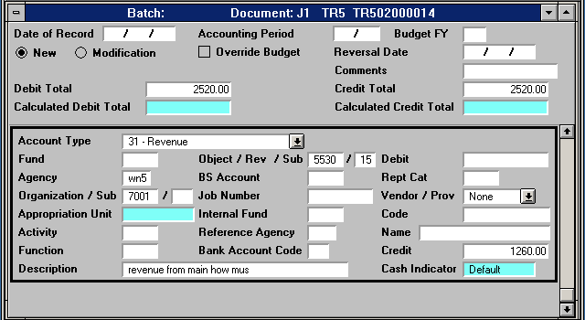

J1 – Journal Voucher with Different Funds (Cross-Funds)
Fill in the blank J1 screen for the credit portion of the Balance Sheet line according to the following examples and instructions.
Complete only the fields indicated.

Enter data in the following fields only (bolded fields are required):
Account Type | Choose the Account Type: 01 Assets
Fund | Type the fund (5110) of the agency and org for the account (TR5 1008) that was debited in this example.
BS Account | Type 1100
Credit | Type the amount being credited to this fund.
Description | Type Balance Sheet Transfer.
The completed J1 screen for the credit portion of the Balance Sheet line looks like this. | 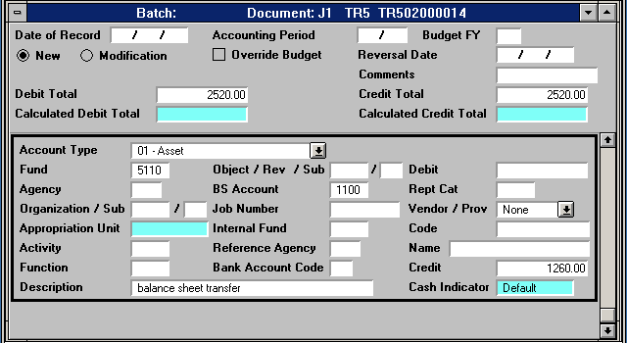

J1 – Journal Voucher with Different Funds (Cross-Funds)
Fill in the blank J1 screen for the debit portion of the Balance Sheet line according to the following examples and instructions.
Complete only the fields indicated.

Enter data in the following fields only (bolded fields are required):
Account Type |  | Choose the Account Type: 01 Assets
Fund |  | Type the fund (5160) of the agency and org for the account (WN5 7001) that was credited in this example.
BS Account |  | Type 1100
Debit |  | Type the amount being debited on this fund.
Description |  | Type Balance Sheet Transfer.
The completed J1 screen for the debit portion of the Balance Sheet line is shown. | 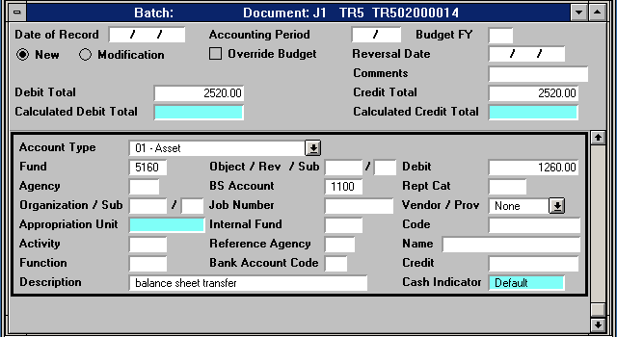

Note: Documents should be approved and then closed. Accountant approvals are required at Levels 4 and 5, therefore, the J1 will remain in the Suspense File until all approval levels are applied and final processing occurs.

